Department of Data Science

LAB MANUAL



DATA STRUCTURE

(BCS-351)

COURSE: B. TECH (DS)

SEM: IIIrd

INSTITUTE VISION AND MISSION

Vision of the Institute
To be a globally recognized institution distinguished by excellence in education, research, innovation, and entrepreneurship, producing competent & socially responsible technocrats for sustainable growth.

Mission of the Institute
- To cultivate a student-centric ecosystem that fosters experiential learning, ethical problem-solving, and sustainability.
- To provide a conducive environment for the professional growth of faculty and staff through research and global collaboration, which contributes to the nation's overall development.
- To nurture a culture of active citizenship through excellence in education, entrepreneurship, and innovation, producing socially responsible and competent technocrats.

DEPARTMENT VISION, MISSION & PEOS

Department Vision

To be a globally recognized leader in data science education, pioneering research, and transformative innovation, shaping ethical and socially responsible data scientists who drive sustainable progress and informed decision-making.

Department Mission
- M1: To foster an adaptive and experiential learning environment that enhances analytical thinking, ethical problem-solving, and the application of AI-driven sustainable data solutions.
- M2: To drive impactful research and global industry collaborations, empowering faculty and students to contribute to cutting-edge advancements in data science and national growth.
- M3: To cultivate a culture of disruptive innovation and entrepreneurial excellence, leveraging data science for addressing critical societal challenges and shaping a responsible digital future.

PROGRAM EDUCATIONAL OBJECTIVES (PEOs)

- PEO1: Graduates will excel in their professional careers by applying advanced data science skills in diverse industries, research institutions, and entrepreneurial ventures.
- PEO2: Graduates will continuously engage in lifelong learning, interdisciplinary research, and professional development to stay at the forefront of advancements in data science and AI.
- PEO3: Graduates will demonstrate leadership, ethical responsibility, and innovative problem-solving skills in addressing complex societal and industrial challenges through data-driven methodologies.

PROGRAM OUTCOMES (POs)

Knowledge and Attitude Profile (WK):
WK1: A systematic, theory-based understanding of the natural sciences applicable to the discipline and awareness of relevant social sciences.
WK2: Conceptually-based mathematics, numerical analysis, data analysis, statistics and formal aspects of computer and information science to support detailed analysis and modelling applicable to the discipline.
WK3: A systematic, theory-based formulation of engineering fundamentals required in the engineering discipline.
WK4: Engineering specialist knowledge that provides theoretical frameworks and bodies of knowledge for the accepted practice areas in the engineering discipline; much is at the forefront of the discipline.
WK5: Knowledge, including efficient resource use, environmental impacts, whole-life cost, re-use of resources, net zero carbon, and similar concepts, that supports engineering design and operations in a practice area.
WK6: Knowledge of engineering practice (technology) in the practice areas in the engineering discipline.
WK7: Knowledge of the role of engineering in society and identified issues in engineering practice in the discipline, such as the professional responsibility of an engineer to public safety and sustainable development.
WK8: Engagement with selected knowledge in the current research literature of the discipline, awareness of the power of critical thinking and creative approaches to evaluate emerging issues.
WK9: Ethics, inclusive behavior and conduct. Knowledge of professional ethics, responsibilities, and norms of engineering practice. Awareness of the need for diversity by reason of ethnicity, gender, age, physical ability etc. with mutual understanding and respect, and of inclusive attitudes.

Program Outcomes | Statement
PO1 | Engineering Knowledge: Apply knowledge of mathematics, natural science, computing, engineering fundamentals and an engineering specialization as specified in WK1 to WK4 respectively to develop to the solution of complex engineering problems.
PO2 | Problem Analysis: Identify, formulate, review research literature and analyze complex engineering problems reaching substantiated conclusions with consideration for sustainable development. (WK1 to WK4)
PO3 | Design/Development of Solutions: Design creative solutions for complex engineering problems and design/develop systems/components/processes to meet identified needs with consideration for the public health and safety, whole-life cost, net zero carbon, culture, society and environment as required. (WK5)
PO4 | Conduct Investigations of Complex Problems: Conduct investigations of complex  engineering problems using research-based knowledge including design of experiments, modelling, analysis & interpretation of data to provide valid conclusions.  (WK8).
PO5 | Engineering Tool Usage: Create, select and apply appropriate techniques, resources and modern engineering & IT tools, including prediction and modelling recognizing their limitations to solve complex engineering problems. (WK2 and WK6)
PO6 | The Engineer and The World: Analyze and evaluate societal and environmental aspects while solving complex engineering problems for its impact on sustainability with reference to economy, health, safety, legal framework, culture and environment. (WK1, WK5, and WK7).
PO7 | Ethics: Apply ethical principles and commit to professional ethics, human values, diversity and inclusion; adhere to national & international laws. (WK9)
PO8 | Individual and Collaborative Team work: Function effectively as an individual, and  as a member or leader in diverse/multi-disciplinary teams.
PO9 | Communication: Communicate effectively and inclusively within the engineering community and society at large, such as being able to comprehend and write effective reports and design documentation, make effective presentations considering cultural, language, and learning differences
PO10 | Project Management and Finance: Apply knowledge and understanding of engineering management principles and economic decision-making and apply these to one’s own work, as a member and leader in a team, and to manage projects and in multidisciplinary environments.
PO11 | Life-Long Learning: Recognize the need for, and have the preparation and ability for i) independent and life-long learning ii) adaptability to new and emerging technologies  and iii) critical thinking in the broadest context of technological change. (WK8)

PROGRAM SPECIFIC OUTCOMES (PSOs)

Program Specific Outcomes (PSO) | Statement  Engineering graduates will be able to:
PSO1 | Design and implement data-driven solutions using advanced machine learning, AI, and big data technologies to solve real-world challenges effectively.
PSO2 | Apply ethical and responsible data science practices to ensure security, privacy, and fairness in data-driven decision-making processes while addressing societal and industrial needs.

Course outcomes:

COs | COURSE OUTCOMES
BCS351.1 | Students will be able to implement arrays, linked lists, stacks, and queues, and understand their applications in problem-solving and apply stack and queue operations to solve computational problems.
BCS351.2 | Students will be able to implement and analyze various searching and sorting algorithms.
BCS351.3 | Students will be able to implement and analyze various searching and sorting algorithms, and apply stack and queue operations to solve computational problems.

CO-PO Mapping:

CO | PO1 | PO2 | PO3 | PO4 | PO5 | PO6 | PO7 | PO8 | PO9 | PO10 | PO11 | PSO1 | PSO2
BCS351.1 | 3 | - | - | - | 2 | - | - | - | - | - | - | 2 | 3
BCS351.2 | 3 | 2 | - | - | 2 | - | - | - | - | - | 2 | 3 | 3
BCS351.3 | 3 | 3 | 2 | 2 | 3 | - | - | - | - | - | 2 | 3 | 3
Average | 3 | 2.5 | 2 | 2 | 2.3 | - | - | - | - | - | 2 | 2.7 | 3

CO-PO-PSO Justification:

CO | PO / PSO | Justification
BCS351.1 | PO1 | Builds foundational understanding of computing and mathematics for solving complex data structure problems.
Implement arrays, linked lists, stacks, queues
 | PO5 | Uses modern IDEs/debuggers and tools for implementation and verification.
 | PSO1 | Helps understand design trade-offs (array vs linked list, etc.) through structured programming.
 | PSO2 | Enables design and testing of efficient programs that meet time and space constraints.
CO | PO / PSO | Justification
BCS351.2 | PO1 | Strengthens algorithmic problem-solving using standard computing principles.
Implement and evaluate searching/sorting algorithms, stack and queue-based problem solving
 | PO2 | Students analyze algorithmic efficiency (time and space complexity) across problem domains.
 | PO5 | Implementation and testing via tools like code profilers or simulators.
 | PO11 | Encourages research into algorithm optimization, instilling a habit of continuous learning.
 | PSO1 | Supports theoretical and practical understanding of search/sort techniques in system design.
 | PSO2 | Develops fast, testable, and reusable logic modules for real-time problem-solving.
CO | PO / PSO | Justification
BCS351.3 | PO1 | Applies computing and mathematical principles to model and solve graph-based problems.
Implement and apply graph algorithms like DFS, BFS, MST
 | PO2 | Analysis of traversal strategies and optimization methods enhances problem-solving skills.
 | PO3 | Involves designing advanced algorithmic solutions using graphs for complex applications.
 | PO4 | Students experiment with various traversal and optimization algorithms and evaluate them.
 | PO5 | Utilizes graph visualization tools or simulators for testing and debugging.
 | PO11 | Motivates learners to explore advanced topics like shortest path or dynamic graphs.
 | PSO1 | Reinforces theoretical CS knowledge (graph theory) and decision-making in design.
 | PSO2 | Critical for building real-time systems such as routing, scheduling, and connectivity tools.

Process of Installing a C Compiler on a Computer
To compile and run C programs, you need a C compiler. The most common options are:
- GCC (GNU Compiler Collection) — Linux / macOS / Windows (via MinGW or WSL)
- Turbo C++ (outdated, but still used in some schools) — Windows
- Microsoft Visual Studio — Windows
- Clang — macOS / Linux / Windows

Step-by-Step Guide

1. Download & Install Visual Studio
- Go to: https://visualstudio.microsoft.com/
- Download Visual Studio Community Edition (free).

2. Install C/C++ Tools
During installation:
- Select the “Desktop development with C++” workload.
- Click "Install" or "Modify" if already installed.
This installs the Microsoft C/C++ Compiler (cl.exe), debugger, libraries, and more.

3. Create a New C Project
- Open Visual Studio.
- Click "Create a new project".
- Search for Empty Project and select it.
- Name your project and click Create.

4. Add a C File
- In Solution Explorer (right panel), right-click the Source Files folder.
- Click Add > New Item.
- Choose C++ File (.cpp).
  - Rename it to main.c to write in C (not C++).
- Click Add.

5. Write Your C Code
Example:
#include <stdio.h>

int main() {
printf("Hello, World!\n");
return 0;
}

6. Build and Run
- Click Ctrl + F5 to build and run the program (without debugging).
- Or click the green "Start" button in the toolbar.

🛠️ Optional: Change Language Mode to C
Visual Studio treats .c files as C automatically. If needed:
- Right-click on project > Properties
- Go to C/C++ > Advanced
- Set Compile As to Compile as C Code (/TC)

Available software to run C Program, are as follows:
IDE Name | Platform | Compiler Support
Code::Blocks | Windows, Linux, macOS | GCC, Clang, MinGW
Dev C++ (Forks) | Windows | GCC (MinGW)
Eclipse CDT | Windows, Linux, macOS | GCC, Clang
NetBeans (with C plugin) | Windows, Linux, macOS | GCC, Clang
Visual Studio Code | Windows, Linux, macOS | GCC, Clang, MSVC
Geany | Windows, Linux, macOS | GCC
KDevelop | Linux, Windows, macOS | GCC, Clang

Minimum System Requirements
- CPU Intel Core i5 @3.20 GHz,
- 8 GB RAM,
- 250 GB SSD,
- 16” Inch Display,
- Windows 10 Professional.

List of Experiments

S.No. | List of Experiments | Prescribed by AKTU / Value-added | CO | Software /IDE Used
1 | Sorting Algorithms:  A. To implement bubble sort.  B. To implement insertion sort.  C. To implement selection sort.  D. To implement quick sort. | AKTU | CO2 | Visual Studio Code
2 | Searching Algorithms:  A. To implement linear search.  B. To implement binary search. | AKTU | CO2 | Visual Studio Code
3. | Stack Operations  A. To implement stack using array.  B. To implement stack using linked list.  C. To implement the conversion of infix notation to postfix notation. | AKTU | CO1 | Visual Studio Code
4 | Queue Implementations  A. To implement queue using linked list.  B. To implement circular queue using linked list.  C. To implement priority queue using array. | AKTU | CO1 | Visual Studio Code
5 | Linked List Structures  A. To implement singly linked list.  B. To implement circular linked list.  C. To implement doubly linked list.  D. To implement polynomial addition | AKTU | CO1 | Visual Studio Code
6 | Trees and Heaps  A. To implement binary search tree using linked list.  B. To implement recursive traversal: Preorder, Postorder, and Inorder.  C. To implement heap sort. | AKTU | CO3 | Visual Studio Code
7 | Graph Algorithms  A. To implement a graph using the adjacent matrix.  B. To implement BFS using linked list.  C. To implement any minimum spanning tree algorithm. | AKTU | CO3 | Visual Studio Code
8 | Sorting & Tree Algorithms:  A. To implement Counting Sort.  B. To implement B+ tree | Value Added | CO1,  CO3 | Visual Studio Code

Experiment No: 1.A

Objective: To implement Bubble Sorting.

Apparatus Used: Visual Studio Code
Hardware Used: CPU Intel Core i5 @3.20 GHz, 8 GB, 250 GB SSD, 16” Inch Display, Windows 10 Professional.
Theory: Bubble Sort is an algorithm that sorts an array from the lowest value to the highest value.

How it works:
- Go through the array, one value at a time.
- For each value, compare the value with the next value.
- If the value is higher than the next one, swap the values so that the highest value comes last.
- Go through the array as many times as there are values in the array.

Pseudocode:
BubbleSort(array, n):
for i from 0 to n-1:
for j from 0 to n-i-2:
if array[j] > array[j+1]:
swap array[j] and array[j+1]

Program:

#include <stdio.h>
void bubbleSort(int arr[], int n) {
int i, j, temp;
// Traverse through all array elements
for (i = 0; i < n - 1; i++) {
// Last i elements are already in place
for (j = 0; j < n - i - 1; j++) {
// Swap if the element is greater than the next
if (arr[j] > arr[j + 1]) {
temp = arr[j];
arr[j] = arr[j + 1];
arr[j + 1] = temp;
}
}
}
}
// Function to print the array
void printArray(int arr[], int size) {
int i;
for (i = 0; i < size; i++)
printf("%d ", arr[i]);
printf("\n");
}
// Main function
int main() {
int arr[] = {64, 25, 12, 22, 11};
int n = sizeof(arr) / sizeof(arr[0]);
printf("Original array: \n");
printArray(arr, n);
bubbleSort(arr, n);
printf("Sorted array: \n");
printArray(arr, n);
return 0;
}

Input and Output Combine Screenshot:
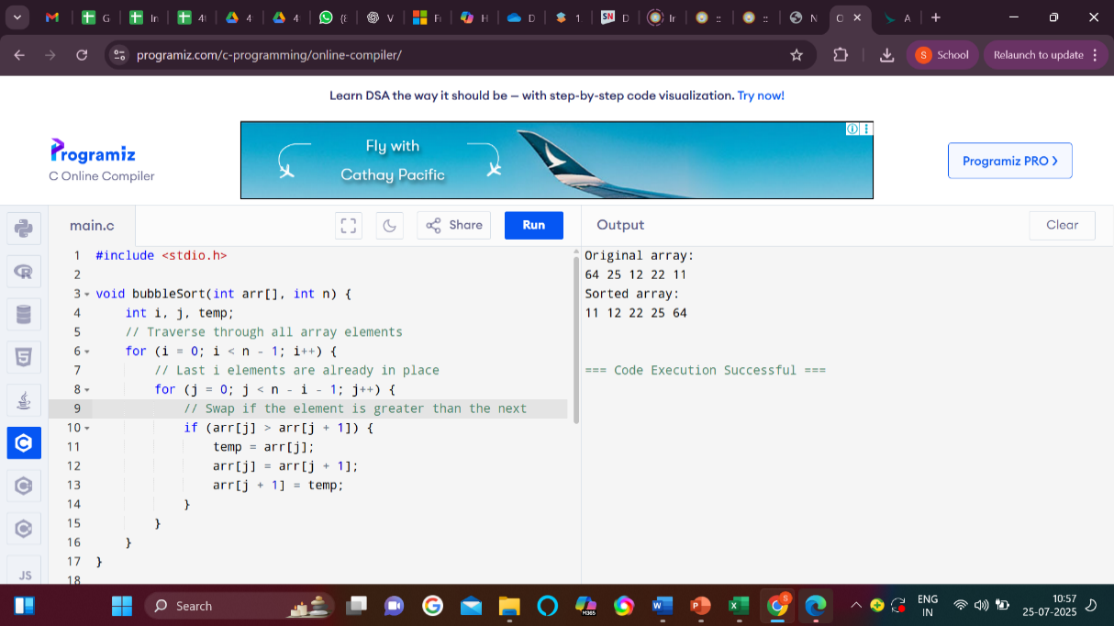
Figure 1.A: Input/Output of the Implementation of Bubble Sorting

Viva Questions:
- What is Bubble Sort and how does it work?
Answer: Bubble Sort is a simple algorithm that repeatedly swaps adjacent elements if they are in the wrong order. It continues until the entire list is sorted.
- What is the time complexity of Bubble Sort in best, average, and worst cases?
Answer: Best case is O(n), average and worst cases are O(n²) due to nested iterations over the array.
- How can Bubble Sort be optimized?
Answer: It can be optimized by using a swapped flag to stop early if no swaps occur in a pass.
- Why is Bubble Sort not suitable for large datasets?
Answer: Because of its O(n²) time complexity, it's inefficient and slow for sorting large amounts of data.
- What is the difference between Bubble Sort and Selection Sort?
Answer: Bubble Sort swaps adjacent elements repeatedly, while Selection Sort selects the minimum element and swaps it once per pass.

Experiment No: 1.B

Objective: To implement Insertion Sorting.

Apparatus Used: Visual Studio Code
Hardware Used: CPU Intel Core i5 @3.20 GHz, 8 GB, 250 GB SSD, 16” Inch Display, Windows 10 Professional.

Theory: Insertion Sort is a simple comparison-based sorting algorithm. It builds the final sorted array one element at a time by comparing each new element to those already sorted and inserting it into its correct position. It is efficient for small or nearly sorted datasets.

Pseudocode:
InsertionSort(array, n):
for i from 1 to n-1:
key = array[i]
j = i - 1
while j >= 0 and array[j] > key:
array[j + 1] = array[j]
j = j - 1
array[j + 1] = key

Program:

#include <stdio.h>

void insertionSort(int arr[], int n) {
int i, key, j;
for (i = 1; i < n; i++) {
key = arr[i];
j = i - 1;

// Move elements that are greater than key to one position ahead
while (j >= 0 && arr[j] > key) {
arr[j + 1] = arr[j];
j = j - 1;
}
arr[j + 1] = key;
}
}

// Function to print the array
void printArray(int arr[], int n) {
int i;
for (i = 0; i < n; i++)
printf("%d ", arr[i]);
printf("\n");
}

// Main function
int main() {
int arr[] = {12, 11, 13, 5, 6};
int n = sizeof(arr) / sizeof(arr[0]);

printf("Original array:\n");
printArray(arr, n);

insertionSort(arr, n);

printf("Sorted array:\n");
printArray(arr, n);

return 0;
}

Screenshot Input with output:
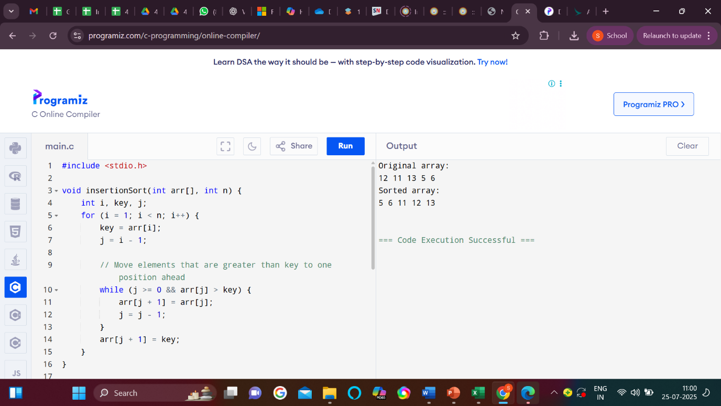
Figure 1.B: Input & Output of the Implementation of Insertion Sort

Viva Questions:

- What is Insertion Sort and how does it work?
Answer: Insertion Sort builds the sorted array one item at a time by comparing and inserting each element into its correct position. It works like sorting playing cards in hand.
- What is the time complexity of Insertion Sort in best and worst cases?
Answer: Best case (already sorted): O(n); Worst case (reverse order): O(n²) due to shifting elements.
- How is Insertion Sort different from Bubble Sort?
Answer: Insertion Sort inserts elements into their correct position, while Bubble Sort repeatedly swaps adjacent elements. Insertion Sort is generally more efficient.
- Is Insertion Sort stable and in-place? Explain.
Answer: Yes, it's stable (maintains relative order of equal elements) and in-place (uses no extra memory).
- When is Insertion Sort preferred over other sorting algorithms?
Answer: It's preferred for small datasets or nearly sorted arrays due to its simplicity and low overhead.

Experiment No: 1.C

Objective: To implement Selection Sorting.

Apparatus Used: Visual Studio Code
Hardware Used: CPU Intel Core i5 @3.20 GHz, 8 GB, 250 GB SSD, 16” Inch Display, Windows 10 Professional.

Theory: Selection Sort is a simple comparison-based sorting algorithm. It works by repeatedly finding the minimum (or maximum) element from the unsorted part and placing it at the beginning (or end). It reduces the problem size one element at a time.

Pseudocode:
SelectionSort(array, n):
for i from 0 to n-1:
minIndex = i
for j from i+1 to n-1:
if array[j] < array[minIndex]:
minIndex = j
swap array[i] and array[minIndex]

Program:

#include <stdio.h>
void selectionSort(int arr[], int n) {
int i, j, min_idx, temp;
// Move boundary of unsorted subarray
for (i = 0; i < n - 1; i++) {
min_idx = i;
// Find the minimum element in unsorted part
for (j = i + 1; j < n; j++) {
if (arr[j] < arr[min_idx])
min_idx = j;
}
// Swap the found minimum with the first element
if (min_idx != i) {
temp = arr[min_idx];
arr[min_idx] = arr[i];
arr[i] = temp;
}
}
}
// Function to print the array
void printArray(int arr[], int size) {
int i;
for (i = 0; i < size; i++)
printf("%d ", arr[i]);
printf("\n");
}
// Main function
int main() {
int arr[] = {29, 10, 14, 37, 13};
int n = sizeof(arr) / sizeof(arr[0]);
printf("Original array:\n");
printArray(arr, n);
selectionSort(arr, n);
printf("Sorted array:\n");
printArray(arr, n);
return 0;
}

Input & Output Screenshot:
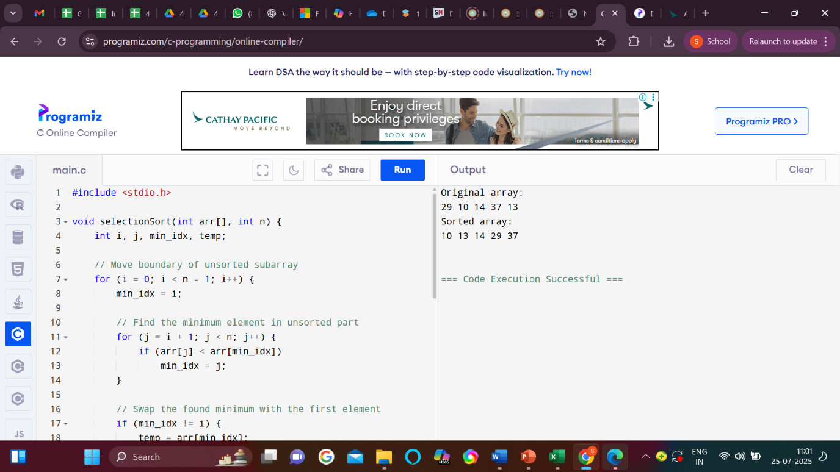
Figure No. 1.C: Input & Output of the Implemention of Selection Sort

Viva Questions:
- What is Selection Sort and how does it work?
Answer: Selection Sort repeatedly selects the smallest element from the unsorted portion and swaps it with the first unsorted element. This process continues until the list is sorted.
- What is the time complexity of Selection Sort in all cases?
Answer: Time complexity is O(n²) in best, average, and worst cases due to two nested loops.
- Is Selection Sort stable? Why or why not?
Answer: No, it's not stable because it may swap non-adjacent elements, changing the order of equal elements.
- How does Selection Sort differ from Insertion Sort?
Answer: Selection Sort selects the minimum and swaps once per pass, while Insertion Sort shifts elements to insert them correctly.
- Why is Selection Sort not preferred for large datasets?
Answer: Due to its O(n²) time complexity and lack of efficiency, it's slow and impractical for large datasets.

Experiment No: 1.D

Objective: To implement Quick Sorting.

Apparatus Used: Visual Studio Code
Hardware Used: CPU Intel Core i5 @3.20 GHz, 8 GB, 250 GB SSD, 16” Inch Display, Windows 10 Professional.
Theory
Quick Sort is a highly efficient sorting algorithm that follows the divide-and-conquer approach. It works by selecting a 'pivot' element from the array and partitioning the other elements into two sub-arrays, according to whether they are less than or greater than the pivot. The sub-arrays are then sorted recursively.

Pseudocode:
1. Start
2. Choose a pivot (e.g., last element)
3. Partition the array:
For each element in the array:
If the element is less than or equal to the pivot, swap it with the element at the
partition index.
Place the pivot in its correct position.
4. Recursively apply Quick Sort to the left and right sub-arrays.
5. End Loop
6. End

Program:

#include <stdio.h>
// Function to swap two elements
void swap(int* a, int* b) {
int temp = *a;
*a = *b;
*b = temp;
}
// Partition function
int partition(int arr[], int low, int high) {
int pivot = arr[high]; // pivot
int i = (low - 1); // index of smaller element
for (int j = low; j < high; j++) {
// If current element is smaller than or equal to pivot
if (arr[j] <= pivot) {
i++; // increment index of smaller element
swap(&arr[i], &arr[j]);
}
}
swap(&arr[i + 1], &arr[high]);
return (i + 1);
}
// QuickSort function
void quickSort(int arr[], int low, int high) {
if (low < high) {
// pi is partitioning index
int pi = partition(arr, low, high);
// Separately sort elements before and after partition
quickSort(arr, low, pi - 1);
quickSort(arr, pi + 1, high);
}
}
// Function to print the array
void printArray(int arr[], int size) {
for (int i = 0; i < size; i++)
printf("%d ", arr[i]);
printf("\n");
}
// Main function
int main() {
int arr[] = {10, 7, 8, 9, 1, 5};
int n = sizeof(arr) / sizeof(arr[0]);
printf("Original array:\n");
printArray(arr, n);
quickSort(arr, 0, n - 1);
printf("Sorted array:\n");
printArray(arr, n);
return 0;
}
Output:

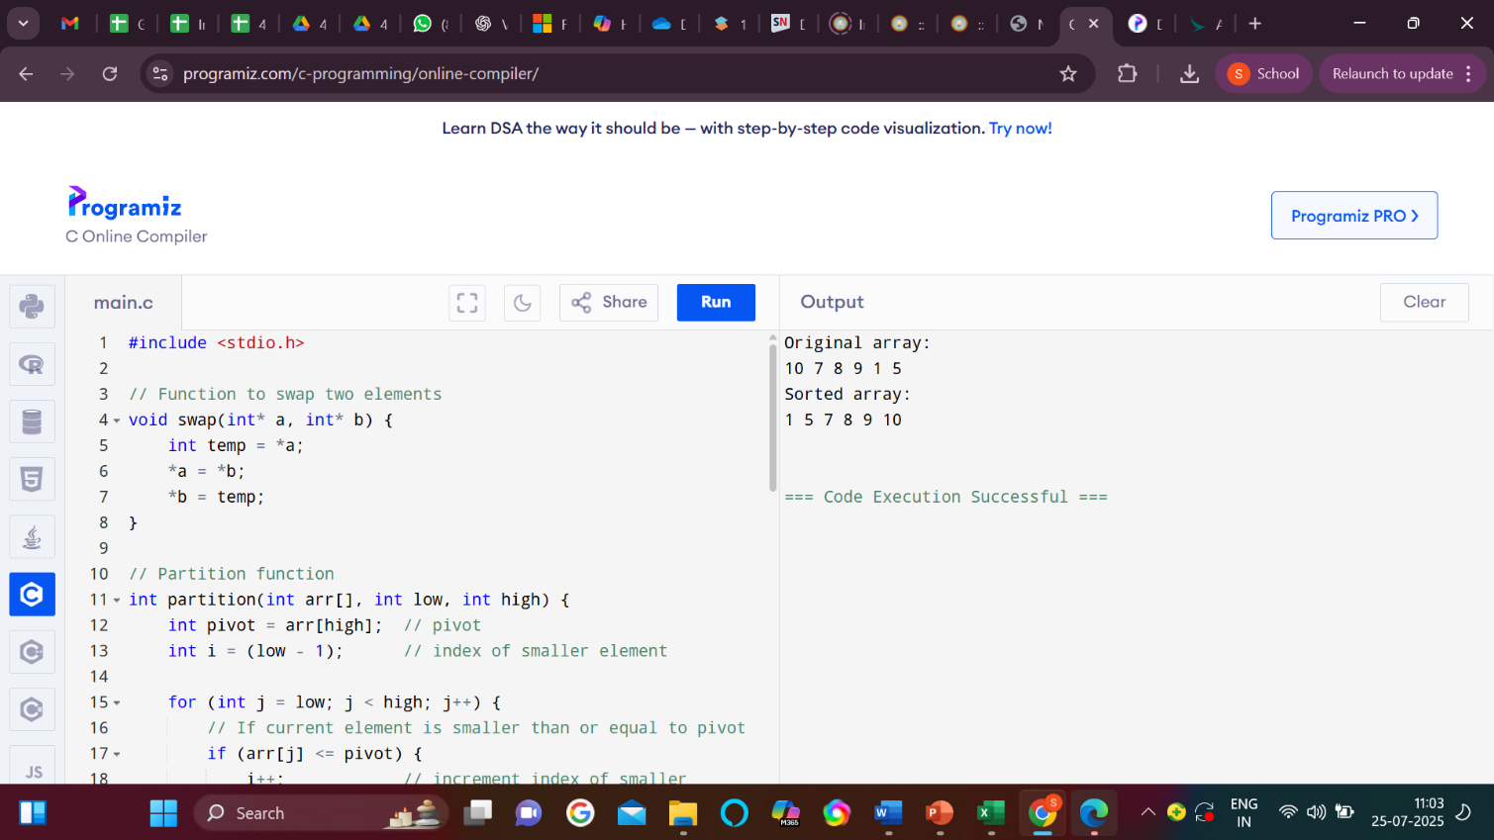

Figure 1.D: Output of the Implementation of Quick Sort
Viva Questions:
- What is the time complexity of Quick Sort in the average, worst, and best cases?
Answer: Best and average case: O(n log n); Worst case (poor pivot): O(n²) due to unbalanced partitions.
- How does Quick Sort differ from Merge Sort?
Answer: Quick Sort is in-place and uses partitioning; Merge Sort uses extra space and merges sorted halves.
- What strategies can be used to choose a pivot effectively?
Answer: Use random pivot, median-of-three, or middle element to reduce chances of worst-case partitions.
- What are the advantages and disadvantages of Quick Sort?
Answer: It’s fast and efficient on average, but has a worst-case time of O(n²) and is not stable by default.
- In what scenarios would you prefer Quick Sort over other sorting algorithms?
Answer: Quick Sort is preferred for large datasets and in-place sorting when average-case performance matters most.

Experiment No: 2.A

Objective: To implement Linear Search.

Apparatus Used: Visual Studio Code
Hardware Used: CPU Intel Core i5 @3.20 GHz, 8 GB, 250 GB SSD, 16” Inch Display, Windows 10 Professional.
Theory:
1. Linear Search:
A simple search algorithm that checks each element in a list until the desired element is
found or the list ends. Time complexity is O(n).

Pseudocode:

Start -> Input Array & Key
Set Index = 0
If Index < Size, Check Element[Index] == Key
If Yes: Print Index & Stop
If No: Increment Index & Repeat
If Index == Size: Print "Not Found"
End

Program:

#include <stdio.h>

// Function to perform linear search
int linearSearch(int arr[], int n, int key) {
for (int i = 0; i < n; i++) {
if (arr[i] == key)
return i; // Return index if found
}
return -1; // Return -1 if not found
}

int main() {
int arr[] = {5, 12, 7, 25, 18};
int n = sizeof(arr) / sizeof(arr[0]);
int key = 25;

int result = linearSearch(arr, n, key);

if (result != -1)
printf("Element %d found at index %d.\n", key, result);
else
printf("Element %d not found in the array.\n", key);

return 0;
}

Input & Output Screenshot:

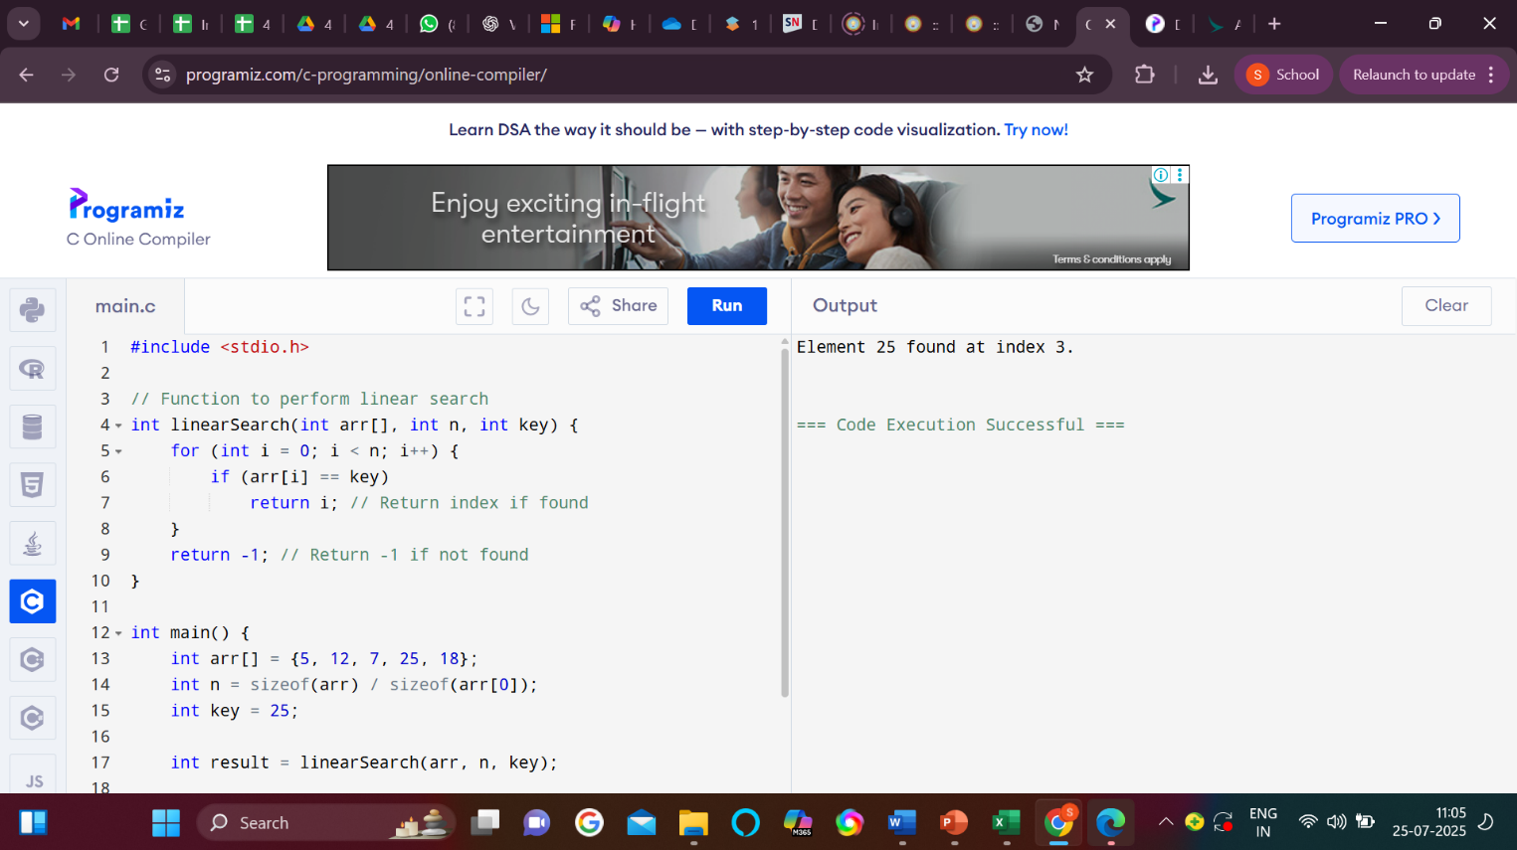

Figure 2.A: Input & Output of the Implementation of Linear Search

Viva Questions:

- Explain the time complexity of linear and binary search.
Anwser: Linear search has O(n) time complexity; binary search has O(log n) but requires a sorted array.
- What is hashing, and why is it useful?
Anwser: Hashing maps keys to indices in a table using a hash function, enabling fast data access in O(1) average time.
- How does collision resolution work in hashing?
Anwser: When two keys map to the same index, collision resolution techniques like chaining or probing are used to store them.
- Can you explain how linear probing works?
Anwser: In linear probing, if a collision occurs, the algorithm checks the next slot linearly until an empty one is found.
- What are the advantages of binary search over linear search?
Anwser: Binary search is much faster on large, sorted data (O(log n)) compared to linear search’s O(n) time.

Experiment No: 2.B

Objective: To implement Binary Search.

Apparatus Used: Visual Studio Code
Hardware Used: CPU Intel Core i5 @3.20 GHz, 8 GB, 250 GB SSD, 16” Inch Display, Windows 10 Professional.
Theory: Binary Search is an efficient search algorithm that works on sorted arrays. It repeatedly divides the search interval in half. If the target value is equal to the middle element, the search is complete. If not, it continues in the left or right half, depending on the value.

Pseudocode:

Start -> Input Sorted Array & Key
Set Low = 0, High = Size - 1
While Low <= High:
Mid = (Low + High) / 2
If Array[Mid] == Key: Print Mid & Stop
If Array[Mid] < Key: Low = Mid + 1
Else: High = Mid - 1
Print "Not Found"
End

Program:

#include <stdio.h>

// Function to perform binary search
int binarySearch(int arr[], int low, int high, int key) {
while (low <= high) {
int mid = low + (high - low) / 2;

// Check if key is at mid
if (arr[mid] == key)
return mid;

// If key is greater, ignore left half
if (arr[mid] < key)
low = mid + 1;

// If key is smaller, ignore right half
else
high = mid - 1;
}

return -1; // Key not found
}

// Function to print array
void printArray(int arr[], int n) {
for (int i = 0; i < n; i++)
printf("%d ", arr[i]);
printf("\n");
}

int main() {
int arr[] = {2, 4, 10, 15, 18, 23, 32}; // Sorted array
int n = sizeof(arr) / sizeof(arr[0]);
int key = 15;

printf("Array:\n");
printArray(arr, n);

int result = binarySearch(arr, 0, n - 1, key);

if (result != -1)
printf("Element %d found at index %d.\n", key, result);
else
printf("Element %d not found in the array.\n", key);

return 0;
}

Input & Output Screenshot:

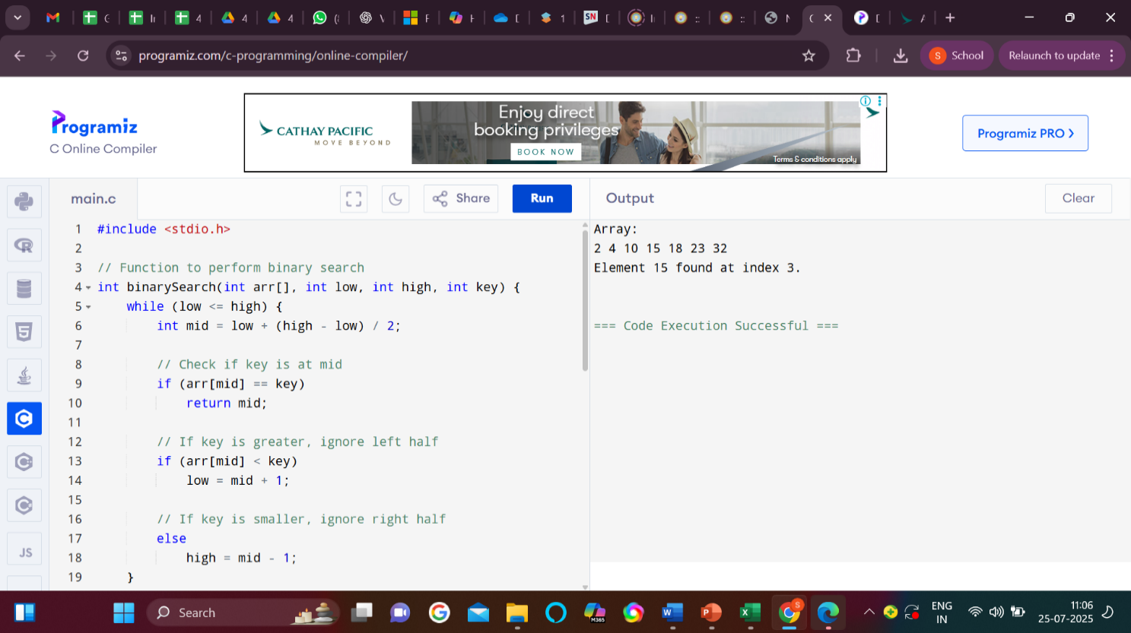

Figure 2.B: Input & Output of the Implementation of Binary Search.

Viva Questions:
- Explain the time complexity of linear and binary search.
Anwser: Linear search takes O(n) time as it checks each element one by one.
Binary search takes O(log n) but works only on sorted arrays.
- What is hashing, and why is it useful?
Anwser: Hashing uses a hash function to map data to a fixed-size table for quick access.
It allows constant time lookups, insertions, and deletions on average.
- How does collision resolution work in hashing?
Anwser: Collision resolution handles cases where multiple keys hash to the same index.
Methods include chaining and open addressing (like linear probing).
- Can you explain how linear probing works?
Anwser: In linear probing, if a spot is occupied, the algorithm checks the next index linearly.
It continues until it finds an empty slot or the key.
- What are the advantages of binary search over linear search?
Anwser: Binary search is faster (O(log n)) and more efficient on large, sorted data.
Linear search is simpler but slower, especially on large lists.

Experiment No: 3.A

Objective: To implement Stack using Array.

Apparatus Used: Visual Studio Code
Hardware Used: CPU Intel Core i5 @3.20 GHz, 8 GB, 250 GB SSD, 16” Inch Display, Windows 10 Professional.

Theory:
A Stack is a linear data structure that follows the LIFO (Last In, First Out) principle. The two primary operations are:
- PUSH – to insert an element
- POP – to remove the top element
When implemented using an array, a top variable keeps track of the index of the top element.
Pseudocode:

Push(x):
if top == MAX - 1:
print "Stack Overflow"
else:
top = top + 1
stack[top] = x

Pop():
if top == -1:
print "Stack Underflow"
else:
x = stack[top]
top = top - 1
return x

Peek():
if top == -1:
print "Stack is Empty"
else:
return stack[top]

- Program:

            - #include <stdio.h>
            - #define MAX 100

            - int stack[MAX];
            - int top = -1;

            - // Function to push an element
            - void push(int value) {
            - if (top == MAX - 1) {
            - printf("Stack Overflow!\n");
            - } else {
            - stack[++top] = value;
            - printf("%d pushed to stack.\n", value);
            - }
            - }

            - // Function to pop an element
            - void pop() {
            - if (top == -1) {
            - printf("Stack Underflow!\n");
            - } else {
            - printf("%d popped from stack.\n", stack[top--]);
            - }
            - }

            - // Function to view the top element
            - void peek() {
            - if (top == -1) {
            - printf("Stack is empty.\n");
            - } else {
            - printf("Top element: %d\n", stack[top]);
            - }
            - }

            - // Function to display stack
            - void display() {
            - if (top == -1) {
            - printf("Stack is empty.\n");
            - } else {
            - printf("Stack elements:\n");
            - for (int i = top; i >= 0; i--) {
            - printf("%d\n", stack[i]);
            - }
            - }
            - }

            - // Main function
            - int main() {
            - int choice, value;

            - while (1) {
            - printf("\n--- Stack Menu ---\n");
            - printf("1. Push\n2. Pop\n3. Peek\n4. Display\n5. Exit\n");
            - printf("Enter choice: ");
            - scanf("%d", &choice);

            - switch (choice) {
            - case 1:
            - printf("Enter value to push: ");
            - scanf("%d", &value);
            - push(value);
            - break;
            - case 2:
            - pop();
            - break;
            - case 3:
            - peek();
            - break;
            - case 4:
            - display();
            - break;
            - case 5:
            - return 0;
            - default:
            - printf("Invalid choice! Try again.\n");
            - }
            - }
            - }

- Input & Output:

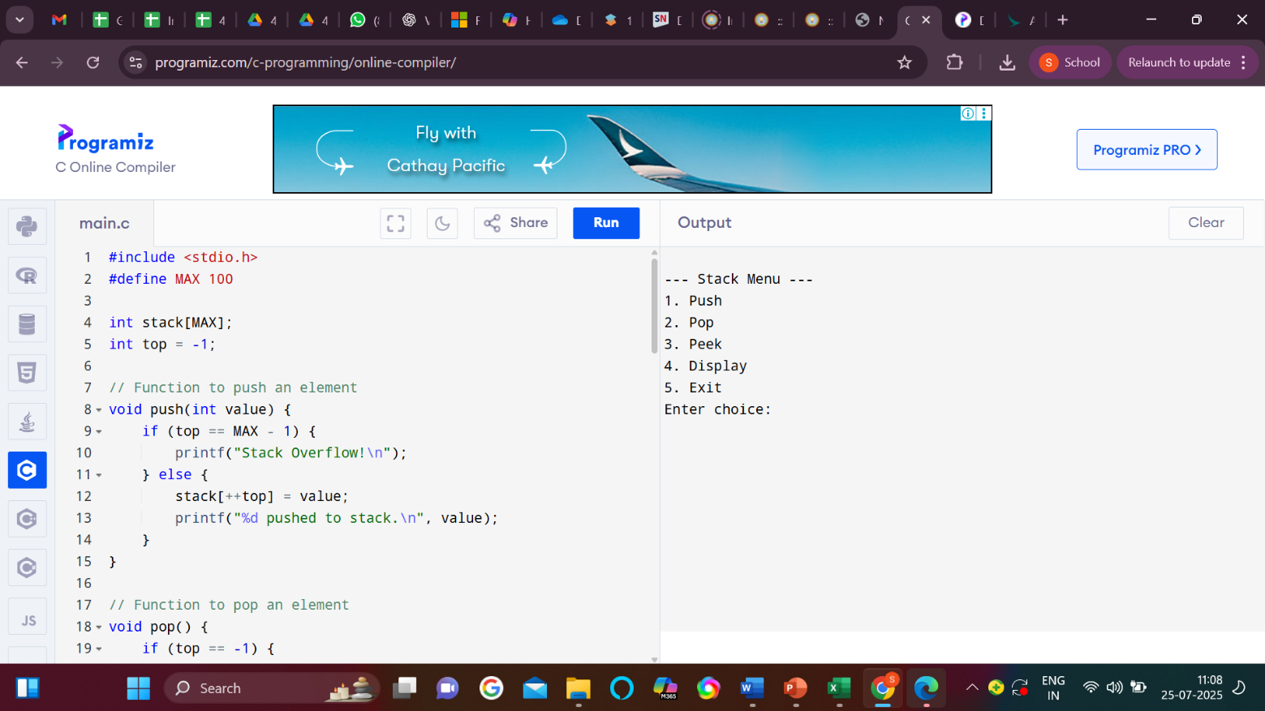

Figure 3.A: Input & Output of the implementation of Stack using Array

Viva Questions:
- What is a stack and how is it implemented using an array?
Anwser: A stack is a LIFO data structure where elements are added and removed from the top.
It's implemented using an array and a variable (e.g., top) to track the index of the last element.
- What are the advantages and limitations of implementing a stack using an array?
Anwser: Advantages: Simple, fast access via indexing.
Limitations: Fixed size, risk of overflow if capacity is exceeded.
- How do you check if a stack is full or empty in array implementation?
Anwser: Stack is empty if top == -1, and full if top == size - 1.
These checks prevent overflow and underflow errors.
- What is the time complexity of push and pop operations in an array-based stack?
Anwser: Both push and pop operations run in O(1) time.
They involve direct index manipulation.
- How do you handle stack overflow and underflow conditions in array implementation?
Anwser: Overflow is handled by checking if the stack is full before pushing.
Underflow is handled by checking if the stack is empty before popping.

Experiment No: 3.B

Objective: To implement Stack using Linked List.

Apparatus Used: Visual Studio Code
Hardware Used: CPU Intel Core i5 @3.20 GHz, 8 GB, 250 GB SSD, 16” Inch Display, Windows 10 Professional.
Theory:
A Stack is a LIFO (Last In, First Out) data structure. When implemented using a linked list, each node contains data and a pointer to the next node. The top of the stack points to the head of the linked list.
- PUSH inserts a new node at the beginning.
- POP removes the node from the beginning.
Pseudocode:
Start
Push/Pop Operation
If Push: Check Stack Overflow
If Yes: Print "Overflow"
Else: Add Element to Stack
If Pop: Check Stack Underflow
If Yes: Print "Underflow"
Else: Remove Element from Stack
End

Program:

#include <stdio.h>
#include <stdlib.h>

// Structure to represent each node in the stack
struct Node {
int data;
struct Node* next;
};

struct Node* top = NULL;

// Function to push an element to the stack
void push(int value) {
struct Node* newNode = (struct Node*)malloc(sizeof(struct Node));
if (!newNode) {
printf("Memory overflow!\n");
return;
}
newNode->data = value;
newNode->next = top;
top = newNode;
printf("%d pushed to stack.\n", value);
}

// Function to pop an element from the stack
void pop() {
if (top == NULL) {
printf("Stack Underflow!\n");
return;
}
struct Node* temp = top;
printf("%d popped from stack.\n", top->data);
top = top->next;
free(temp);
}

// Function to peek at the top element
void peek() {
if (top == NULL) {
printf("Stack is empty.\n");
} else {
printf("Top element: %d\n", top->data);
}
}

// Function to display the stack
void display() {
if (top == NULL) {
printf("Stack is empty.\n");
return;
}
struct Node* temp = top;
printf("Stack elements:\n");
while (temp != NULL) {
printf("%d\n", temp->data);
temp = temp->next;
}
}

// Main function to demonstrate stack operations
int main() {
int choice, value;
while (1) {
printf("\n--- Stack Menu (Linked List) ---\n");
printf("1. Push\n2. Pop\n3. Peek\n4. Display\n5. Exit\n");
printf("Enter your choice: ");
scanf("%d", &choice);

switch (choice) {
case 1:
printf("Enter value to push: ");
scanf("%d", &value);
push(value);
break;
case 2:
pop();
break;
case 3:
peek();
break;
case 4:
display();
break;
case 5:
return 0;
default:
printf("Invalid choice! Please try again.\n");
}
}
}

Input & Output Screenshot:

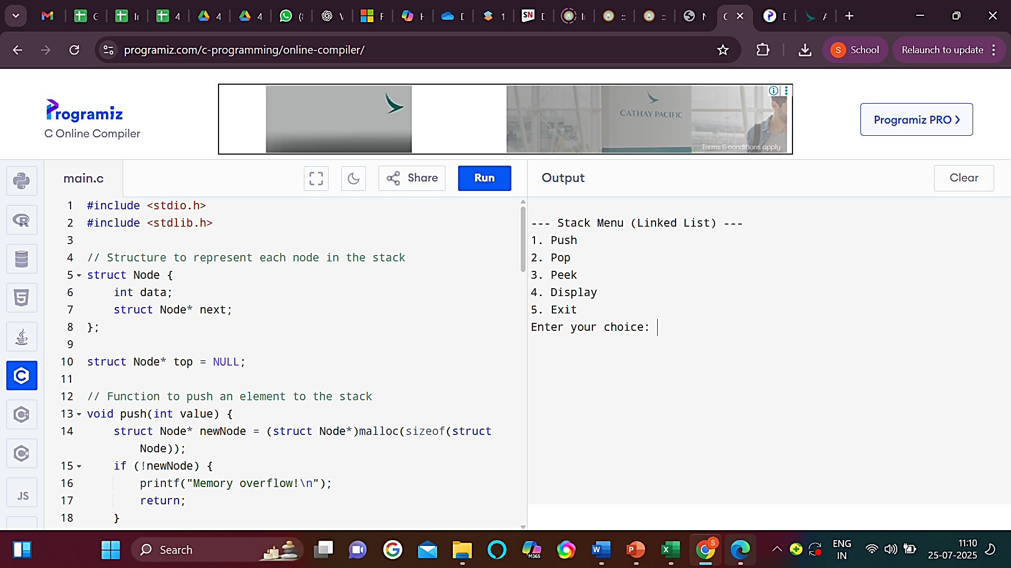
Figure 3.B: Input & Output of the Implementation of Stack using Linked List.

Viva Questions:
- How is a stack implemented using a linked list?
Anwser: A stack uses a linked list where elements are added and removed from the head.
The top points to the head node, and push/pop updates this pointer.
- What are the advantages of using a linked list over an array for stack implementation?
Anwser: Linked lists provide dynamic sizing, avoiding overflow issues.
No need to resize or allocate memory in advance.
- Which end of the linked list is used for push and pop operations in a stack and why?
Anwser: The head is used for both operations to achieve O(1) time complexity.
Modifying the head avoids traversal and ensures efficiency.
- What is the time complexity of stack operations using a linked list?
Anwser: Both push and pop operations take O(1) time.
This is because they involve only head pointer updates.
- How do you detect stack underflow in a linked list implementation?
Anwser: Underflow occurs when pop is called on an empty stack.
Check if the top (head) is null before popping.

Experiment No: 3.C

Objective: To implement the conversion of Infix to Postfix expression.

Apparatus Used: Visual Studio Code
Hardware Used: CPU Intel Core i5 @3.20 GHz, 8 GB, 250 GB SSD, 16” Inch Display, Windows 10 Professional.

Theory:
In Infix expressions, operators are written between operands (e.g., A + B). In Postfix expressions, operators come after operands (e.g., AB+).
To convert infix to postfix:
- Use a stack to temporarily hold operators.
- Operands are added directly to the result.
- Operators are pushed to the stack based on precedence and associativity.
- Parentheses are used to override precedence.
Pseudocode:

InfixToPostfix(infix):
create empty stack for operators
create empty postfix string
for each symbol in infix:
if symbol is operand:
append to postfix
else if symbol is '(':
push to stack
else if symbol is ')':
while top of stack != '(':
pop and append to postfix
pop '(' from stack
else if symbol is operator:
while stack not empty and precedence(symbol) <= precedence(top of stack):
pop and append to postfix
push symbol to stack

while stack not empty:
pop and append to postfix
return postfix

Program:

#include <stdio.h>
#include <ctype.h>
#include <string.h>
#include <stdlib.h>

#define MAX 100

char stack[MAX];
int top = -1;

// Stack functions
void push(char c) {
if (top == MAX - 1)
printf("Stack Overflow\n");
else
stack[++top] = c;
}

char pop() {
if (top == -1)
return -1;
else
return stack[top--];
}

char peek() {
if (top == -1)
return -1;
else
return stack[top];
}

// Function to return precedence of operators
int precedence(char op) {
if (op == '^')
return 3;
else if (op == '*' || op == '/')
return 2;
else if (op == '+' || op == '-')
return 1;
else
return 0;
}

// Function to convert infix to postfix
void infixToPostfix(char* infix) {
char postfix[MAX];
int i = 0, k = 0;
char symbol;

while (infix[i] != '\0') {
symbol = infix[i];

// If operand, add to output
if (isalnum(symbol)) {
postfix[k++] = symbol;
}
// If '(', push to stack
else if (symbol == '(') {
push(symbol);
}
// If ')', pop until '('
else if (symbol == ')') {
while (peek() != '(')
postfix[k++] = pop();
pop(); // Remove '('
}
// If operator
else {
while (precedence(peek()) >= precedence(symbol))
postfix[k++] = pop();
push(symbol);
}

i++;
}
// Pop remaining operators
while (top != -1)
postfix[k++] = pop();

postfix[k] = '\0';

printf("Postfix Expression: %s\n", postfix);
}
// Main
int main() {
char infix[MAX];

printf("Enter Infix Expression (e.g., A+(B*C)): ");
scanf("%s", infix);

infixToPostfix(infix);

return 0;
}

Output:
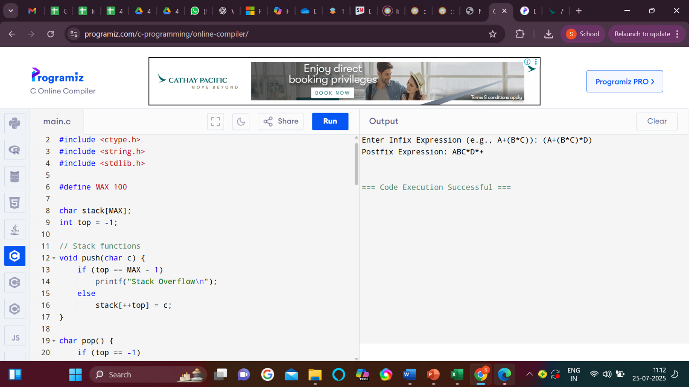
Figure 3.C: Output of the conversion of Infix to Postfix expression.
Viva Questions:
- What is an infix expression?
Anwser: An infix expression places operators between operands, e.g., A + B.
It’s the standard way humans write mathematical expressions.
- Why is postfix notation preferred over infix in some computations?
Anwser: Postfix eliminates the need for parentheses and follows strict operator precedence, making evaluation easier for computers.
- How does the Shunting Yard algorithm work for converting infix to postfix expressions?
Anwser: It uses a stack to reorder operators based on precedence and associativity.
Operands go directly to output; operators are pushed/popped according to rules.
- Give an example of converting an infix expression to postfix using the Shunting Yard algorithm.
Anwser: Infix: (A + B) * C → Postfix: A B + C *
The algorithm handles parentheses and operator precedence via a stack.
- How do you evaluate a postfix expression once it's converted?
Anwser: Scan left to right, push operands, and on an operator, pop two operands, apply the operator, and push the result.

Experiment No: 4.A

Objective: To implement the Queue using Linked List.

Apparatus Used: Visual Studio Code
Hardware Used: CPU Intel Core i5 @3.20 GHz, 8 GB, 250 GB SSD, 16” Inch Display, Windows 10 Professional.

Literature/Theory/ Formula: The Linked List implementation of the queue data structure is discussed and implemented. Print '-1' if the queue is empty. we maintain two pointers, front and rear. The front points to the first item of the queue and rear points to the last item.

- enQueue(): This operation adds a new node after the rear and moves the rear to the next node.
- deQueue(): This operation removes the front node and moves the front to the next node.

Follow the below steps to solve the problem:
- Create a class Node with data members integer data and Node* next
  - A parameterized constructor that takes an integer x value as a parameter and sets data equal to x and next as NULL
- Create a class Queue with data members Node front and rear
- Enqueue Operation with parameter x:
  - Initialize Node* temp with data = x
  - If the rear is set to NULL then set the front and rear to temp and return(Base Case)
  - Else set rear next to temp and then move rear to temp
- Dequeue Operation:
  - If the front is set to NULL return(Base Case)
  - Initialize Node temp with front and set front to its next
  - If the front is equal to NULL then set the rear to NULL
  - Delete temp from the memory

Time Complexity: O(1), The time complexity of both operations enqueue() and dequeue() is O(1) as it only changes a few pointers in both operations
Auxiliary Space: O(1), The auxiliary Space of both operations enqueue() and dequeue() is O(1) as constant extra space is required
Algorithm/Pseudocode:

struct Node {
data
next
}

struct Queue {
front, rear

function enqueue(value):
node = new Node(value)
if front == null:
front = rear = node
else:
rear.next = node
rear = node

function dequeue():
if front == null:
return null
value = front.data
front = front.next
if front == null:
rear = null
return value

function peek():
if front == null:
return null
return front.data

function isEmpty():
return front == null
}

Program:

#include <stdio.h>
#include <stdlib.h>

// Structure for each node of the queue
struct Node {
int data;
struct Node* next;
};

// Front and Rear pointers for Queue
struct Node* front = NULL;
struct Node* rear = NULL;

// Function to enqueue (insert element)
void enqueue(int value) {
struct Node* newNode = (struct Node*)malloc(sizeof(struct Node));
if (!newNode) {
printf("Memory allocation failed!\n");
return;
}

newNode->data = value;
newNode->next = NULL;

if (rear == NULL) {
front = rear = newNode;
} else {
rear->next = newNode;
rear = newNode;
}
printf("%d enqueued to the queue.\n", value);
}

// Function to dequeue (remove element)
void dequeue() {
if (front == NULL) {
printf("Queue Underflow! Queue is empty.\n");
return;
}

struct Node* temp = front;
printf("%d dequeued from the queue.\n", front->data);
front = front->next;

if (front == NULL) rear = NULL; // If queue becomes empty

free(temp);
}

// Function to peek at the front element
void peek() {
if (front == NULL) {
printf("Queue is empty.\n");
} else {
printf("Front element is: %d\n", front->data);
}
}

// Function to display the queue
void display() {
if (front == NULL) {
printf("Queue is empty.\n");
return;
}

struct Node* temp = front;
printf("Queue elements: ");
while (temp != NULL) {
printf("%d ", temp->data);
temp = temp->next;
}
printf("\n");
}

// Main function to demonstrate queue operations
int main() {
int choice, value;

while (1) {
printf("\n--- Queue Menu (Linked List) ---\n");
printf("1. Enqueue\n2. Dequeue\n3. Peek\n4. Display\n5. Exit\n");
printf("Enter your choice: ");
scanf("%d", &choice);

switch (choice) {
case 1:
printf("Enter value to enqueue: ");
scanf("%d", &value);
enqueue(value);
break;
case 2:
dequeue();
break;
case 3:
peek();
break;
case 4:
display();
break;
case 5:
printf("Exiting...\n");
return 0;
default:
printf("Invalid choice! Try again.\n");
}
}
}

Input & Output Screenshot:

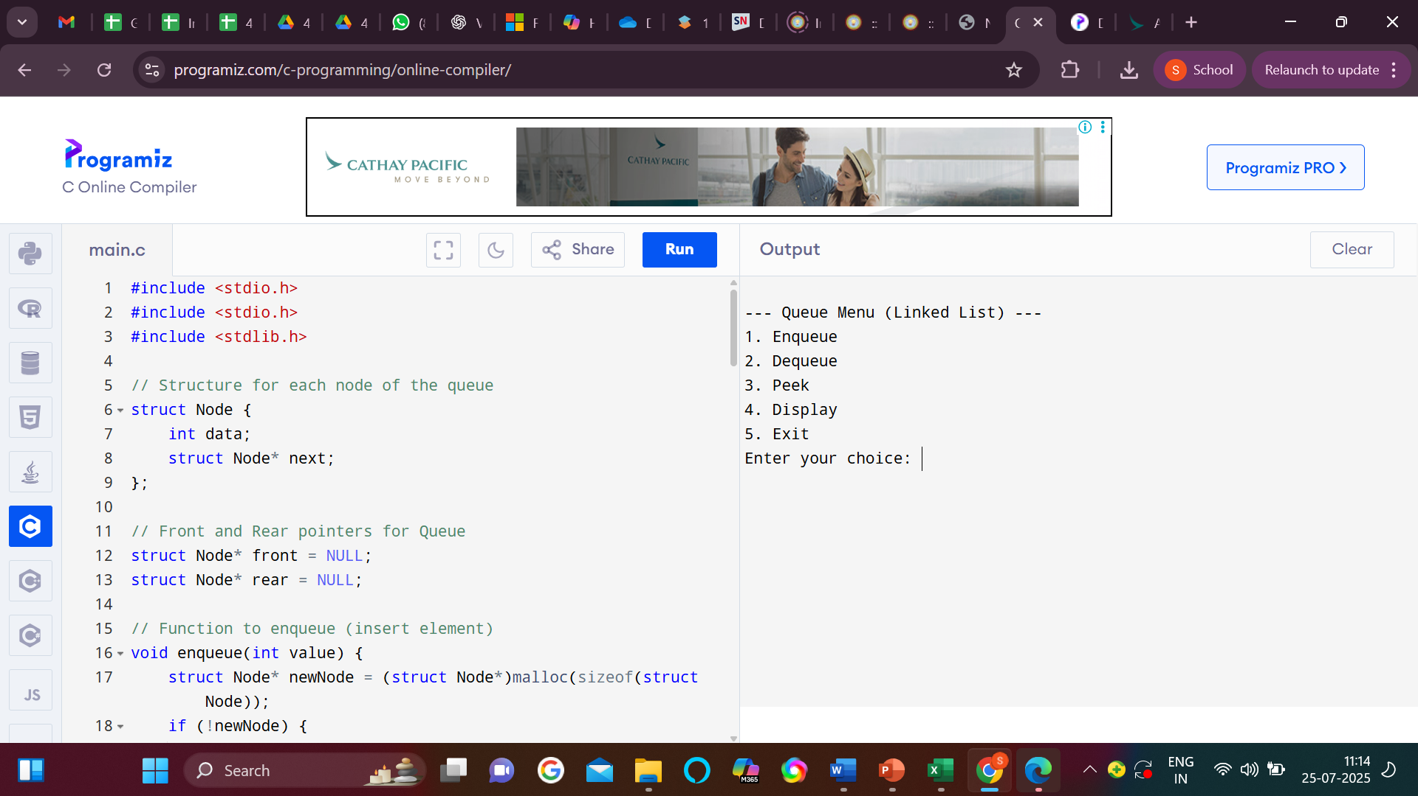
Output:

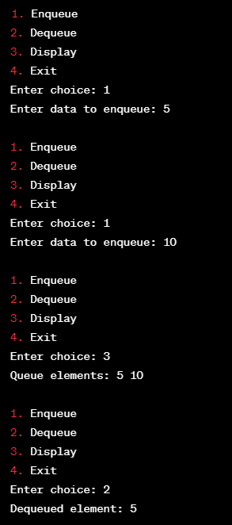

Figure 4.A: Input & Output of the Implementation of the Queue using Linked List.

Viva Questions:

- What is a Queue and how does it differ from other data structures like stacks?
Anwser: A Queue follows FIFO (First In, First Out) order, where elements are added at the rear and removed from the front.
In contrast, a stack follows LIFO (Last In, First Out) order.
- Why would you implement a Queue using a Linked List instead of an array?
Anwser: A linked list allows dynamic memory allocation, avoiding fixed size limits.
It’s more efficient for frequent enqueue/dequeue without shifting elements.
- Explain the process of enqueue and dequeue operations in a Queue implemented using a Linked List.
Anwser: Enqueue inserts a node at the rear; dequeue removes a node from the front.
Both operations run in O(1) time with front and rear pointers.
- How do you handle the case when the Queue is empty during a dequeue operation?
Anwser: Check if the front is null before dequeueing.
If it is, report underflow or return an error/indicator.
- What are the advantages and disadvantages of using a Linked List to implement a Queue?
Anwser: Advantages: Dynamic size, no need for resizing, efficient operations.
Disadvantages: More complex, uses extra memory for pointers.

Experiment No: 4.B

Objective: To implement the circular Queue using Array.

Apparatus Used: Visual Studio Code
Hardware Used: CPU Intel Core i5 @3.20 GHz, 8 GB, 250 GB SSD, 16” Inch Display, Windows 10 Professional.

Literature/Theory/ Formula:A Circular Queue wraps around when it reaches the end of the array. It uses:
- front → points to the first element
- rear → points to the last element
- size → maximum capacity

We use modulo operation to wrap around: (index + 1) % size

Pseudocode:

Initialize:
front ← -1
rear ← -1
size ← N
queue[size]

Function isFull():
return (front == (rear + 1) mod size)

Function isEmpty():
return (front == -1)

Function ENQUEUE(value):
if isFull():
print "Queue Overflow"
return
else if isEmpty():
front ← 0
rear ← 0
else:
rear ← (rear + 1) mod size
queue[rear] ← value

Function DEQUEUE():
if isEmpty():
print "Queue Underflow"
return null
value ← queue[front]
if front == rear:
front ← -1
rear ← -1
else:
front ← (front + 1) mod size
return value

Function PEEK():
if isEmpty():
return null
return queue[front]

Program:

#include <stdio.h>
#define SIZE 5 // Define the size of the circular queue

int queue[SIZE];
int front = -1, rear = -1;

// Function to check if the queue is full
int isFull() {
return (front == (rear + 1) % SIZE);
}

// Function to check if the queue is empty
int isEmpty() {
return (front == -1);
}

// Function to insert an element
void enqueue(int value) {
if (isFull()) {
printf("Queue is Full! Cannot enqueue %d\n", value);
} else {
if (front == -1) front = 0;
rear = (rear + 1) % SIZE;
queue[rear] = value;
printf("%d enqueued to the queue.\n", value);
}
}

// Function to remove an element
void dequeue() {
if (isEmpty()) {
printf("Queue is Empty! Cannot dequeue.\n");
} else {
printf("%d dequeued from the queue.\n", queue[front]);
if (front == rear) {
front = rear = -1; // Queue becomes empty
} else {
front = (front + 1) % SIZE;
}
}
}

// Function to view front element
void peek() {
if (isEmpty()) {
printf("Queue is Empty!\n");
} else {
printf("Front element: %d\n", queue[front]);
}
}

// Function to display the queue
void display() {
if (isEmpty()) {
printf("Queue is Empty!\n");
} else {
printf("Queue elements: ");
int i = front;
while (1) {
printf("%d ", queue[i]);
if (i == rear) break;
i = (i + 1) % SIZE;
}
printf("\n");
}
}

// Main function
int main() {
int choice, value;

while (1) {
printf("\n--- Circular Queue Menu ---\n");
printf("1. Enqueue\n2. Dequeue\n3. Peek\n4. Display\n5. Exit\n");
printf("Enter your choice: ");
scanf("%d", &choice);

switch (choice) {
case 1:
printf("Enter value to enqueue: ");
scanf("%d", &value);
enqueue(value);
break;
case 2:
dequeue();
break;
case 3:
peek();
break;
case 4:
display();
break;
case 5:
return 0;
default:
printf("Invalid choice! Try again.\n");
}
}

return 0;
}

Input & Output Screenshot:
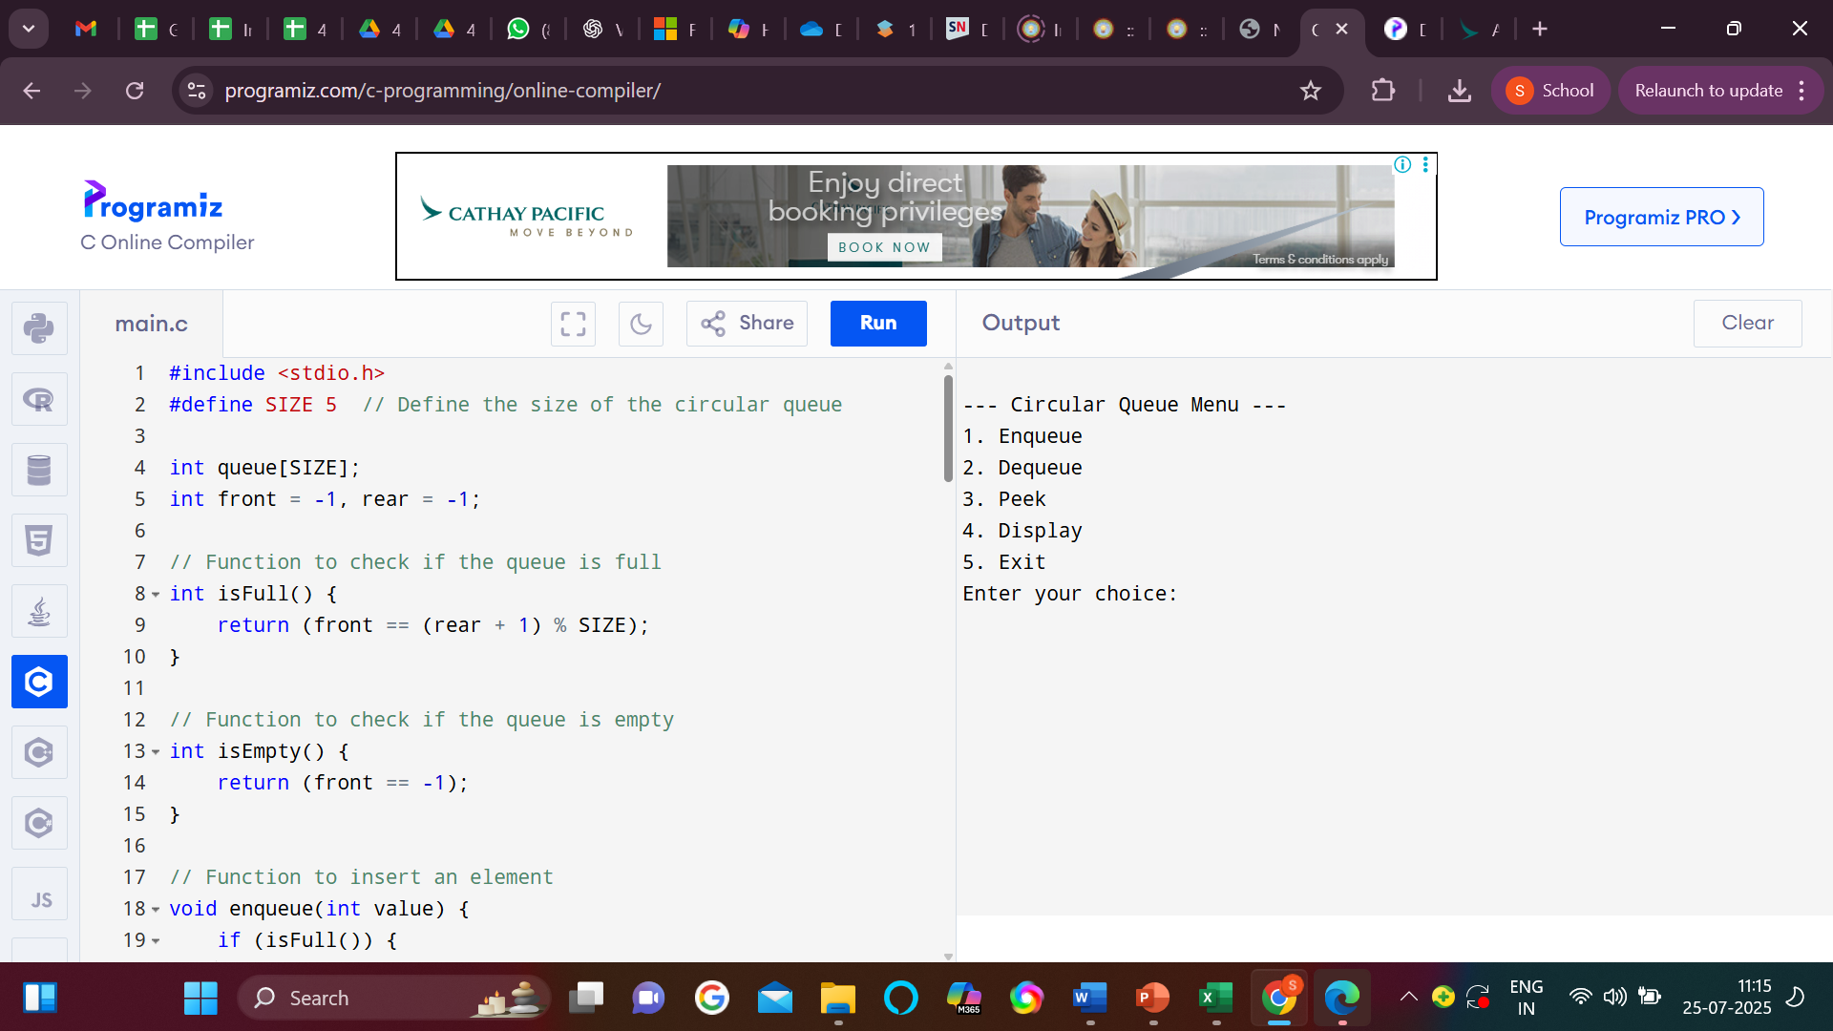

Figure 4.B: Output of the Implementation of the circular Queue using Array

Viva Questions:
- What is a circular queue and how is it different from a simple linear queue?
Answer: A circular queue connects the end of the array back to the front, forming a circle.
Unlike a linear queue, it reuses freed space, avoiding wasted memory.
- Why do we use a circular queue instead of a linear queue in some cases?
Answer: Circular queues optimize space by reusing empty slots.
Linear queues can lead to unused space even when not full.
- How do you determine if a circular queue is full or empty?
Answer: It's full if (rear + 1) % size == front; empty if front == -1.
These conditions prevent overflow and underflow.
- Explain how the front and rear pointers move in a circular queue implemented using an array.
Answer: Both pointers move circularly using (index + 1) % size.
This ensures they wrap around to the beginning when reaching the end.
- What is the advantage of using a circular queue over a normal queue implemented with an array?
Answer: Circular queues maximize memory usage by reusing freed space.
They prevent the need for shifting elements or resizing.

Experiment No: 4.C

Objective: To implement the Priority Queue using Linked List.

Apparatus Used: Visual Studio Code
Hardware Used: CPU Intel Core i5 @3.20 GHz, 8 GB, 250 GB SSD, 16” Inch Display, Windows 10 Professional.
Literature/Theory/ Formula:
In Priority Queue , Each node contains:
- data — value to store
- priority — the priority of the value (lower number = higher priority)
- next — pointer to the next node
Pseudocode:
Class Node:
data
priority
next

Class PriorityQueue:
head ← null

Method insert(data, priority):
newNode ← new Node(data, priority)

if head is null OR priority < head.priority:
newNode.next ← head
head ← newNode
else:
current ← head
while current.next ≠ null AND current.next.priority ≤ priority:
current ← current.next
newNode.next ← current.next
current.next ← newNode

Method remove():
if head is null:
print "Queue is empty"
else:
temp ← head
head ← head.next
delete temp

Method peek():
if head is null:
return "Queue is empty"
else:
return head.data

Method isEmpty():
return head = null

Program:

#include <stdio.h>
#include <stdlib.h>

// Define a structure for a node in the priority queue
struct Node {
int data;
int priority;
struct Node* next;
};

// Function to create a new node
struct Node* createNode(int data, int priority) {
struct Node* newNode = (struct Node*)malloc(sizeof(struct Node));
newNode->data = data;
newNode->priority = priority;
newNode->next = NULL;
return newNode;
}

// Function to insert an element into the priority queue
void enqueue(struct Node** head, int data, int priority) {
struct Node* newNode = createNode(data, priority);

if (*head == NULL || priority < (*head)->priority) {
newNode->next = *head;
*head = newNode;
} else {
struct Node* current = *head;
while (current->next != NULL && current->next->priority <= priority) {
current = current->next;
}
newNode->next = current->next;
current->next = newNode;
}
}

// Function to remove and return the element with the highest priority
int dequeue(struct Node** head) {
if (*head == NULL) {
printf("Priority queue is empty.\n");
exit(1);
}

struct Node* temp = *head;
int data = temp->data;
*head = (*head)->next;
free(temp);
return data;
}

// Function to check if the priority queue is empty
int isEmpty(struct Node* head) {
return head == NULL;
}
// Function to display the elements in the priority queue
void display(struct Node* head) {
if (head == NULL) {
printf("Priority queue is empty.\n");
return;
}

printf("Priority queue elements:\n");
while (head != NULL) {
printf("Data: %d, Priority: %d\n", head->data, head->priority);
head = head->next;
}
printf("\n");
}

int main() {
struct Node* pq = NULL;
int choice, data, priority;

while (1) {
printf("1. Enqueue\n");
printf("2. Dequeue\n");
printf("3. Exit\n");
printf("Enter your choice: ");
scanf("%d", &choice);

switch (choice) {
case 1:
printf("Enter data and priority to enqueue: ");
scanf("%d %d", &data, &priority);
enqueue(&pq, data, priority);
display(pq);
break;
case 2:
if (!isEmpty(pq)) {
printf("Dequeued element: %d\n", dequeue(&pq));
display(pq);
} else {
printf("Priority queue is empty.\n");
}
break;
case 3:
exit(0);
default:
printf("Invalid choice. Please try again.\n");
}
}

return 0;
}

Output:

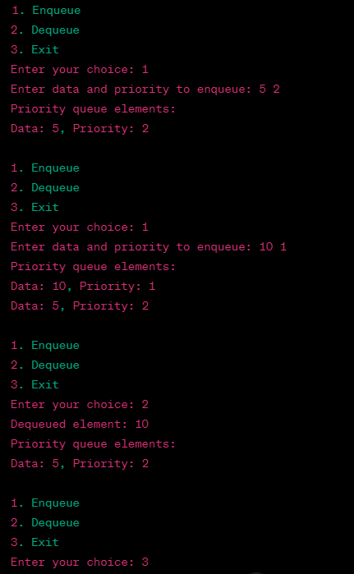

Figure 4.C: Output of the Implementation of the Priority Queue using Linked List.

Viva Questions:
- What is a priority queue and how does it differ from a regular queue?
Anwser: A priority queue removes elements based on priority, not insertion order.
In a regular queue, elements follow FIFO without priority consideration.
- How do you maintain the order of elements in a priority queue implemented with a linked list?
Anwser: Insert elements in sorted order based on priority.
The highest (or lowest) priority element stays at the front.
- What is the time complexity of insertion and deletion operations in a priority queue using a linked list?
Anwser: Insertion takes O(n) (to find correct position), and deletion takes O(1) (from front).
This maintains correct priority order.
- How do you handle multiple elements with the same priority in the priority queue?
Anwser: Insert them in the order they arrive to maintain stability.
This ensures FIFO among equal-priority elements.
- Why might a linked list be preferred over an array for implementing a priority queue?
Anwser: Linked lists offer dynamic size and easier insertion at any point.
Arrays may require shifting or resizing, which is less efficient.

Experiment No: 5.A

Objective: To implement the Singly Linked List.

Apparatus Used: Visual Studio Code
Hardware Used: CPU Intel Core i5 @3.20 GHz, 8 GB, 250 GB SSD, 16” Inch Display, Windows 10 Professional.

Theory: A Singly Linked List is a linear data structure where each element (called a node) contains two parts:
- data — stores the actual value
- next — a pointer/reference to the next node in the list
The last node points to null indicating the end of the list. It allows efficient insertion and deletion from the front and middle but has no backward traversal.
Pseudocode:

Class Node:
data
next

Class SinglyLinkedList:
head ← null

Method insertAtBeginning(data):
newNode ← new Node(data)
newNode.next ← head
head ← newNode

Method insertAtEnd(data):
newNode ← new Node(data)
if head is null:
head ← newNode
else:
current ← head
while current.next ≠ null:
current ← current.next
current.next ← newNode

Method deleteFromBeginning():
if head is null:
print "List is empty"
else:
head ← head.next

Method display():
current ← head
while current ≠ null:
print current.data
current ← current.next

Program:

#include <stdio.h>
#include <stdlib.h>

// Define a structure for a single linked list node
struct Node {
int data;
struct Node* next;
};

// Function to insert a new node at the beginning of the list
void insertAtBeginning(struct Node** head, int data) {
struct Node* newNode = (struct Node*)malloc(sizeof(struct Node));
newNode->data = data;
newNode->next = *head;
*head = newNode;
}

// Function to insert a new node at the end of the list
void insertAtEnd(struct Node** head, int data) {
struct Node* newNode = (struct Node*)malloc(sizeof(struct Node));
newNode->data = data;
newNode->next = NULL;

if (*head == NULL) {
*head = newNode;
return;
}

struct Node* current = *head;
while (current->next != NULL) {
current = current->next;
}
current->next = newNode;
}

// Function to insert a new node at a specific position in the list
void insertAtPosition(struct Node** head, int data, int position) {
if (position < 0) {
printf("Invalid position. Position must be non-negative.\n");
return;
}

if (position == 0) {
insertAtBeginning(head, data);
return;
}

struct Node* newNode = (struct Node*)malloc(sizeof(struct Node));
newNode->data = data;
newNode->next = NULL;

struct Node* current = *head;
int currentPosition = 0;

while (current != NULL && currentPosition < position - 1) {
current = current->next;
currentPosition++;
}

if (current == NULL) {
printf("Invalid position. Position exceeds the length of the list.\n");
return;
}

newNode->next = current->next;
current->next = newNode;
}

// Function to delete a node at the beginning of the list
void deleteAtBeginning(struct Node** head) {
if (*head == NULL) {
printf("The list is already empty.\n");
return;
}

struct Node* temp = *head;
*head = (*head)->next;
free(temp);
}

// Function to delete a node at the end of the list
void deleteAtEnd(struct Node** head) {
if (*head == NULL) {
printf("The list is already empty.\n");
return;
}

if ((*head)->next == NULL) {
free(*head);
*head = NULL;
return;
}

struct Node* current = *head;
while (current->next->next != NULL) {
current = current->next;
}
free(current->next);
current->next = NULL;
}

// Function to delete a node at a specific position in the list
void deleteAtPosition(struct Node** head, int position) {
if (*head == NULL) {
printf("The list is already empty.\n");
return;
}

if (position < 0) {
printf("Invalid position. Position must be non-negative.\n");
return;
}

if (position == 0) {
deleteAtBeginning(head);
return;
}

struct Node* current = *head;
struct Node* prev = NULL;

int currentPosition = 0;

while (current != NULL && currentPosition < position) {
prev = current;
current = current->next;
currentPosition++;
}

if (current == NULL) {
printf("Invalid position. Position exceeds the length of the list.\n");
return;
}

prev->next = current->next;
free(current);
}

// Function to display the elements of the list
void display(struct Node* head) {
struct Node* current = head;
while (current != NULL) {
printf("%d -> ", current->data);
current = current->next;
}
printf("NULL\n");
}

int main() {
struct Node* head = NULL;
int choice, data, position;

while (1) {
printf("1. Insert at the beginning\n");
printf("2. Insert at the end\n");
printf("3. Insert at a specific position\n");
printf("4. Delete at the beginning\n");
printf("5. Delete at the end\n");
printf("6. Delete at a specific position\n");
printf("7. Display\n");
printf("8. Quit\n");
printf("Enter your choice: ");
scanf("%d", &choice);

switch (choice) {
case 1:
printf("Enter data to insert at the beginning: ");
scanf("%d", &data);
insertAtBeginning(&head, data);
break;
case 2:
printf("Enter data to insert at the end: ");
scanf("%d", &data);
insertAtEnd(&head, data);
break;
case 3:
printf("Enter data to insert: ");
scanf("%d", &data);
printf("Enter position to insert at: ");
scanf("%d", &position);
insertAtPosition(&head, data, position);
break;
case 4:
deleteAtBeginning(&head);
break;
case 5:
deleteAtEnd(&head);
break;
case 6:
printf("Enter position to delete at: ");
scanf("%d", &position);
deleteAtPosition(&head, position);
break;
case 7:
display(head);
break;
case 8:
exit(0);
default:
printf("Invalid choice. Please try again.\n");
}
}

return 0;
}

Output:

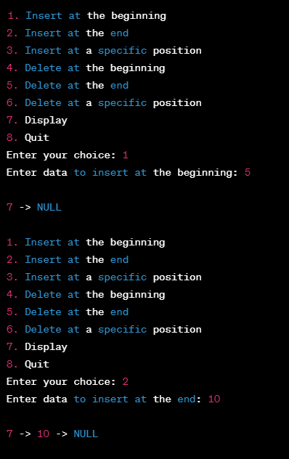

Figure 5.A: Output of the Implementation of the Singly Linked List

Viva Questions:
- What is a singly linked list and how does it differ from an array?
Anwser: A singly linked list is a collection of nodes where each node points to the next node.
Unlike arrays, it provides dynamic sizing and non-contiguous memory storage.
- How do you insert a new node at the beginning of a singly linked list?
Anwser: Create a new node, set its next to the current head, then update head to the new node.
This operation takes O(1) time.
- What are the advantages of using a singly linked list over an array?
Anwser: It allows dynamic memory allocation and efficient insertions/deletions.
No need to shift elements or define a fixed size.
- How do you traverse a singly linked list?
Anwser: Start from the head and follow each node’s next pointer until null.
Visit or process each node during the traversal.
- What happens if you try to delete a node from an empty singly linked list?
Anwser: The operation fails or throws an underflow error.
Always check if head is null before deletion.

Experiment No: 5.B

Objective: To implement the Circular Linked List.

Apparatus Used: Visual Studio Code
Hardware Used: CPU Intel Core i5 @3.20 GHz, 8 GB, 250 GB SSD, 16” Inch Display, Windows 10 Professional.

Theory: A Circular Linked List is a variation of a linked list where the last node points back to the first node instead of null. This forms a circle, allowing traversal to continue indefinitely. It can be singly or doubly linked. Circular linked lists are useful for applications that require cyclic iteration over the data.

Pseudocode:
plaintext
CopyEdit
Class Node:
data
next

Class CircularLinkedList:
head ← null

Method insertAtEnd(data):
newNode ← new Node(data)
if head is null:
head ← newNode
newNode.next ← head
else:
current ← head
while current.next ≠ head:
current ← current.next
current.next ← newNode
newNode.next ← head

Method deleteFromBeginning():
if head is null:
print "List is empty"
else if head.next = head:
head ← null
else:
current ← head
while current.next ≠ head:
current ← current.next
current.next ← head.next
head ← head.next

Method display():
if head is null:
print "List is empty"
return
current ← head
do:
print current.data
current ← current.next
while current ≠ head

Program:

#include <stdio.h>
#include <stdlib.h>

// Define a structure for a circular singly linked list node
struct Node {
int data;
struct Node* next;
};

// Function to insert a new node at the beginning of the circular list
void insertAtBeginning(struct Node** head, int data) {
struct Node* newNode = (struct Node*)malloc(sizeof(struct Node));
newNode->data = data;

if (*head == NULL) {
*head = newNode;
newNode->next = *head;
} else {
struct Node* current = *head;
while (current->next != *head) {
current = current->next;
}
current->next = newNode;
newNode->next = *head;
*head = newNode;
}
}

// Function to delete a node with a given value from the circular list
void deleteNode(struct Node** head, int key) {
if (*head == NULL) {
printf("The circular list is empty.\n");
return;
}

struct Node* current = *head;
struct Node* prev = NULL;

do {
if (current->data == key) {
if (prev == NULL) {
struct Node* last = *head;
while (last->next != *head) {
last = last->next;
}
last->next = current->next;
*head = current->next;
} else {
prev->next = current->next;
}
free(current);
printf("Node with data %d deleted from the circular list.\n", key);
return;
}
prev = current;
current = current->next;
} while (current != *head);

printf("Node with data %d not found in the circular list.\n", key);
}

// Function to display the elements of the circular list
void display(struct Node* head) {
if (head == NULL) {
printf("The circular list is empty.\n");
return;
}

struct Node* current = head;
do {
printf("%d -> ", current->data);
current = current->next;
} while (current != head);
printf("...\n"); // Indicates the circular structure
}

int main() {
struct Node* head = NULL;
int choice, data, key;

while (1) {
printf("1. Insert at the beginning\n");
printf("2. Delete a node\n");
printf("3. Display\n");
printf("4. Quit\n");
printf("Enter your choice: ");
scanf("%d", &choice);

switch (choice) {
case 1:
printf("Enter data to insert at the beginning: ");
scanf("%d", &data);
insertAtBeginning(&head, data);
break;
case 2:
printf("Enter data to delete: ");
scanf("%d", &key);
deleteNode(&head, key);
break;
case 3:
printf("Circular Linked List:\n");
display(head);
break;
case 4:
exit(0);
default:
printf("Invalid choice. Please try again.\n");
}
}

return 0;
}

Output:

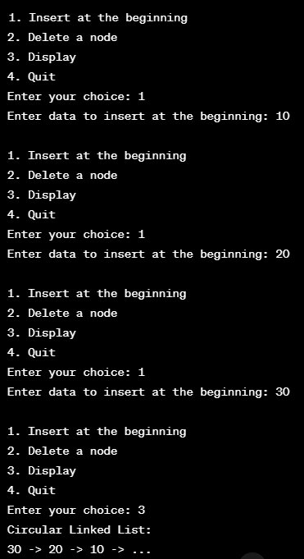

Figure 5.B: Output of the Implementation of the Circular Linked List.

Viva Questions:
- What is a circular linked list and how does it differ from a singly linked list?
Anwser: In a circular linked list, the last node points back to the head, forming a circle. In a singly linked list, the last node points to null.
- How do you identify the end of a circular linked list during traversal?
Anwser: Start from the head and continue until the current node's next is head again.This indicates a full cycle and the end of traversal.

Experiment No: 5.C

Objective: To implement the Doubly Linked List.

Apparatus Used: Visual Studio Code
Hardware Used: CPU Intel Core i5 @3.20 GHz, 8 GB, 250 GB SSD, 16” Inch Display, Windows 10 Professional.

Theory: A Doubly Linked List is a linked list where each node contains three parts:
- data — the value stored
- prev — pointer/reference to the previous node
- next — pointer/reference to the next node
This allows traversal in both forward and backward directions. It makes operations like insertion and deletion more flexible compared to singly linked lists.
Pseudocode:
Class Node:
data
prev
next

Class DoublyLinkedList:
head ← null

Method insertAtBeginning(data):
newNode ← new Node(data)
newNode.next ← head
newNode.prev ← null
if head ≠ null:
head.prev ← newNode
head ← newNode

Method insertAtEnd(data):
newNode ← new Node(data)
if head is null:
head ← newNode
newNode.prev ← null
newNode.next ← null
else:
current ← head
while current.next ≠ null:
current ← current.next
current.next ← newNode
newNode.prev ← current
newNode.next ← null

Method deleteFromBeginning():
if head is null:
print "List is empty"
else:
head ← head.next
if head ≠ null:
head.prev ← null

Method displayForward():
current ← head
while current ≠ null:
print current.data
current ← current.next

Method displayBackward():
current ← head
if current is null:
return
while current.next ≠ null:
current ← current.next
while current ≠ null:
print current.data
current ← current.prev

Program:

#include <stdio.h>
#include <stdlib.h>
// Define a structure for a doubly linked list node
struct Node {
int data;
struct Node* prev;
struct Node* next;
};
// Function to insert a new node at the beginning of the doubly linked list
void insertAtBeginning(struct Node** head, int data) {
struct Node* newNode = (struct Node*)malloc(sizeof(struct Node));
newNode->data = data;
newNode->prev = NULL;

if (*head == NULL) {
newNode->next = NULL;
*head = newNode;
} else {
newNode->next = *head;
(*head)->prev = newNode;
*head = newNode;
}
}
// Function to insert a new node at the end of the doubly linked list
void insertAtEnd(struct Node** head, int data) {
struct Node* newNode = (struct Node*)malloc(sizeof(struct Node));
newNode->data = data;
newNode->next = NULL;

if (*head == NULL) {
newNode->prev = NULL;
*head = newNode;
} else {
struct Node* current = *head;
while (current->next != NULL) {
current = current->next;
}
current->next = newNode;
newNode->prev = current;
}
}
// Function to delete a node with a given value from the doubly linked list
void deleteNode(struct Node** head, int key) {
if (*head == NULL) {
printf("The doubly linked list is empty.\n");
return;
}
struct Node* current = *head;
while (current != NULL) {
if (current->data == key) {
if (current->prev != NULL) {
current->prev->next = current->next;
} else {
*head = current->next;
}

if (current->next != NULL) {
current->next->prev = current->prev;
}

free(current);
printf("Node with data %d deleted from the doubly linked list.\n", key);
return;
}
current = current->next;
}

printf("Node with data %d not found in the doubly linked list.\n", key);
}

// Function to display the elements of the doubly linked list
void display(struct Node* head) {
if (head == NULL) {
printf("The doubly linked list is empty.\n");
return;
}
struct Node* current = head;
while (current != NULL) {
printf("%d <-> ", current->data);
current = current->next;
}
printf("NULL\n");
}
int main() {
struct Node* head = NULL;
int choice, data, key;

while (1) {
printf("1. Insert at the beginning\n");
printf("2. Insert at the end\n");
printf("3. Delete a node\n");
printf("4. Display\n");
printf("5. Quit\n");
printf("Enter your choice: ");
scanf("%d", &choice);
switch (choice) {
case 1:
printf("Enter data to insert at the beginning: ");
scanf("%d", &data);
insertAtBeginning(&head, data);
break;
case 2:
printf("Enter data to insert at the end: ");
scanf("%d", &data);
insertAtEnd(&head, data);
break;
case 3:
printf("Enter data to delete: ");
scanf("%d", &key);
deleteNode(&head, key);
break;
case 4:
printf("Doubly Linked List:\n");
display(head);
break;
case 5:
exit(0);
default:
printf("Invalid choice. Please try again.\n");
}
}

return 0;
}

Output:

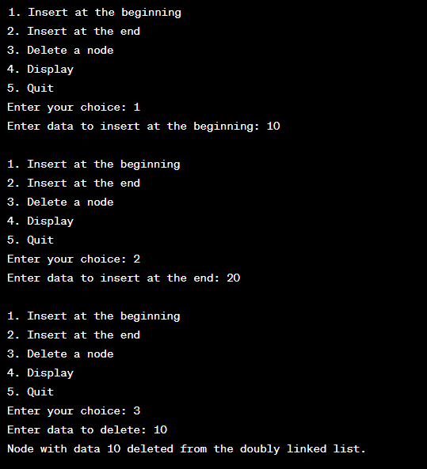

Figure 5.C: Output of the Implementation of the Doubly Linked List

Viva Questions:
- What is a doubly linked list and how does it differ from a singly linked list?
Anwser: A doubly linked list has nodes with next and prev pointers, allowing bidirectional traversal.A singly linked list only has next pointers and allows one-way traversal.
- How do you insert a node at the beginning of a doubly linked list?
Anwser: Create a new node, set its next to the current head and prev to null.
Update the old head’s prev to the new node and set head to the new node.
- Explain how backward traversal is possible in a doubly linked list.
Anwser: Each node has a prev pointer, allowing traversal from the tail to the head.
Start at the tail and follow the prev links.
- What are the advantages and disadvantages of doubly linked lists?
Anwser: Advantages: Easy bidirectional traversal, efficient insertion/deletion from both ends.Disadvantages: Uses more memory and is more complex to manage than singly linked lists.
- How do you delete a node from the beginning of a doubly linked list?
Anwser: Move head to head.next, then set the new head's prev to null.
Free the memory of the original head node.

Experiment No: 5.D

Objective: To implement Polynomial addition.

Apparatus Used: Visual Studio Code
Hardware Used: CPU Intel Core i5 @3.20 GHz, 8 GB, 250 GB SSD, 16” Inch Display, Windows 10 Professional.
Theory:
Polynomial is a mathematical expression involving terms with variables and coefficients (e.g., 3x² + 2x + 1).
In programming, linked lists are commonly used to represent polynomials, where each node contains:
- Coefficient
- Exponent
- Pointer to the next term
Polynomial addition involves traversing two polynomial lists and:
- Adding coefficients of terms with the same exponent
- Keeping unmatched terms as they are

Pseudocode:
Node:
coeff, exp
next

AddPoly(poly1, poly2):
create new list result
while poly1 and poly2:
if poly1.exp == poly2.exp:
sum = poly1.coeff + poly2.coeff
insert sum and exp to result
move poly1 and poly2
else if poly1.exp > poly2.exp:
insert poly1 term to result
move poly1
else:
insert poly2 term to result
move poly2
append remaining terms from poly1 or poly2 to result
return result

Program:

#include <stdio.h>
#include <stdlib.h>

// Define a structure for a polynomial term
struct Term {
int coefficient;
int exponent;
struct Term* next;
};

// Function to create a new term
struct Term* createTerm(int coef, int exp) {
struct Term* newTerm = (struct Term*)malloc(sizeof(struct Term));
newTerm->coefficient = coef;
newTerm->exponent = exp;
newTerm->next = NULL;
return newTerm;
}

// Function to insert a term into a polynomial
void insertTerm(struct Term** poly, int coef, int exp) {
struct Term* newTerm = createTerm(coef, exp);

if (*poly == NULL) {
*poly = newTerm;
} else {
struct Term* current = *poly;
struct Term* prev = NULL;

while (current != NULL && current->exponent > exp) {
prev = current;
current = current->next;
}

if (current != NULL && current->exponent == exp) {
current->coefficient += coef;
free(newTerm);
} else {
newTerm->next = current;
if (prev != NULL) {
prev->next = newTerm;
} else {
*poly = newTerm;
}
}
}
}

// Function to display a polynomial
void displayPolynomial(struct Term* poly) {
if (poly == NULL) {
printf("0\n");
return;
}

while (poly != NULL) {
printf("%dx^%d", poly->coefficient, poly->exponent);
if (poly->next != NULL) {
printf(" + ");
}
poly = poly->next;
}
printf("\n");
}

// Function to add two polynomials
struct Term* addPolynomials(struct Term* poly1, struct Term* poly2) {
struct Term* result = NULL;

while (poly1 != NULL || poly2 != NULL) {
int coef1 = 0, coef2 = 0;
int exp1 = -1, exp2 = -1;

if (poly1 != NULL) {
coef1 = poly1->coefficient;
exp1 = poly1->exponent;
poly1 = poly1->next;
}

if (poly2 != NULL) {
coef2 = poly2->coefficient;
exp2 = poly2->exponent;
poly2 = poly2->next;
}

int sum = coef1 + coef2;
insertTerm(&result, sum, exp1); // Add the terms to the result polynomial
}

return result;
}

int main() {
struct Term* poly1 = NULL;
struct Term* poly2 = NULL;
struct Term* result = NULL;

int coef, exp, terms;

printf("Enter the number of terms in the first polynomial: ");
scanf("%d", &terms);

printf("Enter the terms (coefficient exponent) for the first polynomial:\n");
for (int i = 0; i < terms; i++) {
scanf("%d %d", &coef, &exp);
insertTerm(&poly1, coef, exp);
}

printf("Enter the number of terms in the second polynomial: ");
scanf("%d", &terms);

printf("Enter the terms (coefficient exponent) for the second polynomial:\n");
for (int i = 0; i < terms; i++) {
scanf("%d %d", &coef, &exp);
insertTerm(&poly2, coef, exp);
}

printf("First polynomial: ");
displayPolynomial(poly1);

printf("Second polynomial: ");
displayPolynomial(poly2);

result = addPolynomials(poly1, poly2);

printf("Result of addition: ");
displayPolynomial(result);

// Free memory
struct Term* temp;
while (poly1 != NULL) {
temp = poly1;
poly1 = poly1->next;
free(temp);
}
while (poly2 != NULL) {
temp = poly2;
poly2 = poly2->next;
free(temp);
}
while (result != NULL) {
temp = result;
result = result->next;
free(temp);
}

return 0;
}

Output:

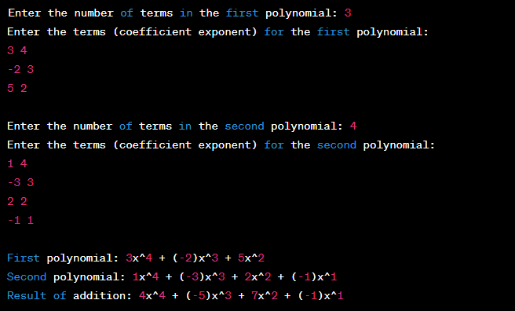

Figure 5.D: Output of the implementation of Polynomial addition

Viva Questions:
- How are polynomials represented in linked lists?
Anwser: Each node in the linked list stores a coefficient and an exponent.
Nodes are usually arranged in descending order of exponents.
- How does polynomial addition work?
Anwser: Traverse both lists simultaneously, comparing exponents.
Add coefficients if exponents match, else copy the term with the higher exponent.
- What happens when terms with the same exponent are found?
Anwser: Their coefficients are added, and a single node is created for the resulting term. If the sum is zero, the term can be skipped.
- Why is a linked list preferred over arrays for polynomial operations?
Anwser: Linked lists allow dynamic size and efficient insertion/deletion of terms.
Arrays waste space when exponents are sparse or unordered.
- Can polynomial multiplication also be done using linked lists?
Anwser: Yes, multiply each term of the first list with every term of the second.
Combine like terms using a new linked list to store the result

Experiment No: 6.A

Objective: To implement Binary search tree using Linked List.

Apparatus Used: Visual Studio Code
Hardware Used: CPU Intel Core i5 @3.20 GHz, 8 GB, 250 GB SSD, 16” Inch Display, Windows 10 Professional.

Theory:
A Binary Search Tree (BST) is a binary tree where each node contains:
- data — a value,
- left — pointer/reference to the left child node (values less than the node’s data),
- right — pointer/reference to the right child node (values greater than the node’s data).
BST maintains an ordered structure allowing fast search, insertion, and deletion operations (average O(log n) time).
Pseudocode:
Class Node:
data
left
right

Class BST:
root ← null

Method insert(node, data):
if node is null:
node ← new Node(data)
return node
if data < node.data:
node.left ← insert(node.left, data)
else if data > node.data:
node.right ← insert(node.right, data)
return node

Method search(node, data):
if node is null OR node.data = data:
return node
if data < node.data:
return search(node.left, data)
else:
return search(node.right, data)

Method inorderTraversal(node):
if node is not null:
inorderTraversal(node.left)
print node.data
inorderTraversal(node.right)

Program:

#include <stdio.h>
#include <stdlib.h>

// Structure for a Node
struct Node {
int data;
struct Node* left;
struct Node* right;
};

// Function to create a new Node
struct Node* createNode(int data) {
struct Node* newNode = (struct Node*)malloc(sizeof(struct Node));
newNode->data = data;
newNode->left = newNode->right = NULL;
return newNode;
}

// Function to insert a Node into the BST
struct Node* insert(struct Node* root, int data) {
if (root == NULL) {
return createNode(data);
}

if (data < root->data) {
root->left = insert(root->left, data);
} else if (data > root->data) {
root->right = insert(root->right, data);
}

return root;
}

// Function to print the BST in inorder traversal
void inorderTraversal(struct Node* root) {
if (root != NULL) {
inorderTraversal(root->left);
printf("%d ", root->data);
inorderTraversal(root->right);
}
}

int main() {
struct Node* root = NULL;
int choice, data;

while (1) {
printf("Binary Search Tree Menu:\n");
printf("1. Insert a node\n");
printf("2. Print in-order traversal\n");
printf("3. Exit\n");
printf("Enter your choice: ");
scanf("%d", &choice);

switch (choice) {
case 1:
printf("Enter data to insert: ");
scanf("%d", &data);
root = insert(root, data);
break;
case 2:
printf("In-order traversal: ");
inorderTraversal(root);
printf("\n");
break;
case 3:
exit(0);
default:
printf("Invalid choice!\n");
}
}

return 0;
}

Output:

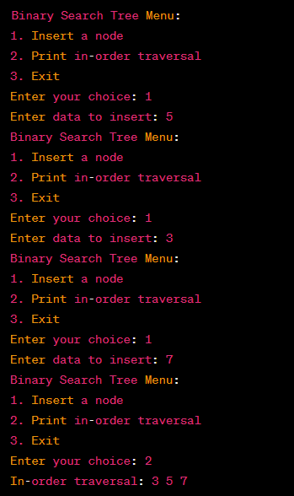

Figure 6.A: Output of the implementation of Binary search tree using Linked List

Viva Questions:
- What is a Binary Search Tree and how is it different from a binary tree?
Anwser: A Binary Search Tree (BST) is a binary tree where left < root < right for all nodes. A regular binary tree has no ordering rules for node values.
- How does the insert operation work in a BST?
Anwser: Compare the new value with the current node and recursively insert left or right. Place the new node where the correct empty position is found.
- What are the time complexities of search, insertion, and deletion in a BST?
Anwser: Average case: O(log n); Worst case (unbalanced tree): O(n). Balanced BSTs maintain efficient performance.
- Explain the inorder traversal of a BST and its significance.
Anwser: Inorder traversal visits nodes in Left → Root → Right order.It produces a sorted sequence of values in a BST

Experiment No: 6.B

Objective: To implement recursive traversal: Preorder, Postorder, Inorder.

Apparatus Used: Visual Studio Code
Hardware Used: CPU Intel Core i5 @3.20 GHz, 8 GB, 250 GB SSD, 16” Inch Display, Windows 10 Professional.

Theory:
In a binary tree, recursive traversals visit nodes in different orders:
- Preorder (Root, Left, Right): Visit the current node first, then recursively traverse the left subtree, followed by the right subtree.
- Inorder (Left, Root, Right): Recursively traverse the left subtree, visit the current node, then traverse the right subtree.
- Postorder (Left, Right, Root): Recursively traverse the left subtree, then the right subtree, and finally visit the current node.
Pseudocode:
Method Preorder(node):
if node is null:
return
print node.data
Preorder(node.left)
Preorder(node.right)

Method Inorder(node):
if node is null:
return
Inorder(node.left)
print node.data
Inorder(node.right)

Method Postorder(node):
if node is null:
return
Postorder(node.left)
Postorder(node.right)
print node.data

Program:

#include <stdio.h>
#include <stdlib.h>

// Define a structure for a binary tree node
struct Node {
int data;
struct Node* left;
struct Node* right;
};

// Function to create a new binary tree node
struct Node* createNode(int data) {
struct Node* newNode = (struct Node*)malloc(sizeof(struct Node));
newNode->data = data;
newNode->left = NULL;
newNode->right = NULL;
return newNode;
}

// Function to build a binary tree using user input
struct Node* buildTree() {
int data;
printf("Enter data (or -1 for empty node): ");
scanf("%d", &data);

if (data == -1) {
return NULL;
}

struct Node* root = createNode(data);
printf("Enter left child of %d:\n", data);
root->left = buildTree();
printf("Enter right child of %d:\n", data);
root->right = buildTree();

return root;
}

// Function for pre-order traversal
void preOrder(struct Node* root) {
if (root != NULL) {
printf("%d ", root->data);
preOrder(root->left);
preOrder(root->right);
}
}

// Function for in-order traversal
void inOrder(struct Node* root) {
if (root != NULL) {
inOrder(root->left);
printf("%d ", root->data);
inOrder(root->right);
}
}

// Function for post-order traversal
void postOrder(struct Node* root) {
if (root != NULL) {
postOrder(root->left);
postOrder(root->right);
printf("%d ", root->data);
}
}

int main() {
struct Node* root = NULL;
printf("Enter the elements of the binary tree:\n");
root = buildTree();
printf("Binary Tree Traversals:\n");
printf("Pre-order traversal: ");
preOrder(root);
printf("\n");
printf("In-order traversal: ");
inOrder(root);
printf("\n");
printf("Post-order traversal: ");
postOrder(root);
printf("\n");

// Free memory (optional)
// You can add code here to free the dynamically allocated memory for the tree
return 0;
}

Output:

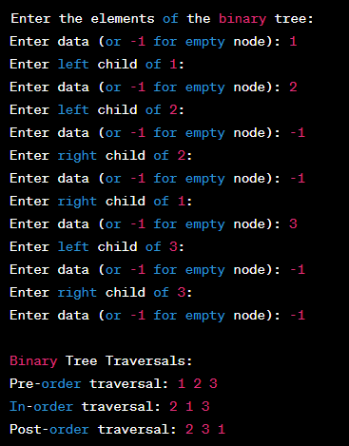

Figure 6.B: Output of the implementation of recursive traversal: Preorder, Postorder, Inorder.

Viva Questions:
- What is the difference between preorder, inorder, and postorder traversal?
- Preorder: Root → Left → Right
- Inorder: Left → Root → Right
- Postorder: Left → Right → Root
- In what order are the nodes visited in an inorder traversal of a binary search tree?
Nodes are visited in ascending sorted order: Left subtree → Node → Right subtree.
- Why do we use recursion for tree traversals? Can tree traversal be implemented iteratively?
Recursion simplifies traversal using the call stack for backtracking.
Yes, tree traversal can be done iteratively using an explicit stack.
- What are some practical applications of preorder, inorder, and postorder traversals?
- Preorder: Copying a tree, prefix expression generation
- Inorder: Sorting BST elements
- Postorder: Deleting a tree, postfix evaluation
- How does the base condition in recursive traversal functions prevent infinite recursion?
The base case checks if the current node is null.
It stops further recursive calls, preventing infinite loops
18

Experiment No: 6.C

Objective: To implement Heap Sort.

Apparatus Used: Visual Studio Code
Hardware Used: CPU Intel Core i5 @3.20 GHz, 8 GB, 250 GB SSD, 16” Inch Display, Windows 10 Professional.

Theory: Heap Sort is a comparison-based sorting technique based on a binary heap data structure. It first builds a max heap from the input array, then repeatedly extracts the maximum element from the heap and places it at the end of the array, reducing the heap size each time. The process results in a sorted array.

Pseudocode:

Method heapSort(arr):
n ← length of arr

// Build max heap
for i ← (n/2) - 1 down to 0:
heapify(arr, n, i)

// Extract elements one by one from heap
for i ← n-1 down to 1:
swap(arr[0], arr[i]) // Move current root to end
heapify(arr, i, 0) // call max heapify on the reduced heap

Method heapify(arr, n, i):
largest ← i
left ← 2*i + 1
right ← 2*i + 2

if left < n and arr[left] > arr[largest]:
largest ← left

if right < n and arr[right] > arr[largest]:
largest ← right

if largest ≠ i:
swap(arr[i], arr[largest])
heapify(arr, n, largest)

Program:

#include<stdio.h>
void heapsort(int[],int);
void heapify(int[],int);
void adjust(int[],int);
main() {
int n,i,a[50];
system("clear");
printf("\nEnter the limit:");
scanf("%d",&n);
printf("\nEnter the elements:");
for (i=0;i<n;i++)
scanf("%d",&a[i]);
heapsort(a,n);
printf("\nThe Sorted Elements Are:\n");
for (i=0;i<n;i++)
printf("\t%d",a[i]);
printf("\n");
}
void heapsort(int a[],int n) {
int i,t;
heapify(a,n);
for (i=n-1;i>0;i--) {
t = a[0];
a[0] = a[i];
a[i] = t;
adjust(a,i);
}
}
void heapify(int a[],int n) {
int k,i,j,item;
for (k=1;k<n;k++) {
item = a[k];
i = k;
j = (i-1)/2;
while((i>0)&&(item>a[j])) {
a[i] = a[j];
i = j;
j = (i-1)/2;
}
a[i] = item;
}
}
void adjust(int a[],int n) {
int i,j,item;
j = 0;
item = a[j];
i = 2*j+1;
while(i<=n-1) {
if(i+1 <= n-1)
if(a[i] <a[i+1])
i++;
if(item<a[i]) {
a[j] = a[i];
j = i;
i = 2*j+1;
} else
break;
}
a[j] = item;
}

Output:

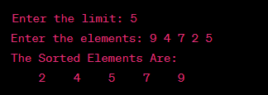

Figure 6.C: Output of the implementation of Heap Sort.

Viva Questions:
- What is heap sort and how does it work?
Heap sort is a comparison-based sorting algorithm that uses a binary heap.
It builds a heap, then repeatedly extracts the root (max/min) to sort the array.
- What is a max heap and how is it used in heap sort?
A max heap is a binary tree where each parent is greater than or equal to its children.
Heap sort uses it to place the largest element at the root for extraction.
- What is the time complexity of heap sort in best, average, and worst cases?
Time complexity is O(n log n) in all cases.
It offers consistent performance regardless of input.
- How does the heapify function work?
Heapify ensures the heap property by comparing a node with its children and swapping if needed.
It recursively applies this down the subtree to maintain order.
- What are the advantages of heap sort compared to other sorting algorithms like quicksort or mergesort?
Heap sort has no worst-case degradation and needs no extra space (in-place).
Unlike quicksort, it guarantees O(n log n) performance in all cases.

Experiment No: 7.A

Objective: To implement a graph using adjacent matrix.

Apparatus Used:Turbo C compiler, gcc compiler (VS Code, Dev C), GCC compiler or any standard C programming environment (e.g., Code:Blocks, Dev C++, Turbo C++), Operating System: Windows / Linux / macOS Text Editor or IDE

Theory:

An adjacency matrix is a 2D array used to represent a graph. The rows and columns correspond to nodes (vertices) of the graph. The element at position (i, j) indicates whether there is an edge from vertex i to vertex j. For unweighted graphs, the value is typically 1 (edge exists) or 0 (no edge). For weighted graphs, the matrix holds the weight of the edge or a special value (like 0 or ∞) if no edge exists.

Pseudocode:
Class Graph:
vertices ← number of vertices
adjacencyMatrix ← 2D array of size vertices x vertices initialized with 0

Method addEdge(u, v):
adjacencyMatrix[u][v] ← 1
// For undirected graph, also add:
adjacencyMatrix[v][u] ← 1

Method removeEdge(u, v):
adjacencyMatrix[u][v] ← 0
// For undirected graph, also remove:
adjacencyMatrix[v][u] ← 0

Method isEdge(u, v):
return adjacencyMatrix[u][v] == 1

Method displayMatrix():
for i in 0 to vertices-1:
for j in 0 to vertices-1:
print adjacencyMatrix[i][j], end=" "
print new line

Program:

#include <stdio.h>
#define MAX_NODES 100
// Define the graph structure
struct Graph {
int vertices;
int adjacencyMatrix[MAX_NODES][MAX_NODES];
};

// Function to initialize the graph
void initGraph(struct Graph *graph, int vertices) {
graph->vertices = vertices;
// Initialize the adjacency matrix with zeros
for (int i = 0; i < vertices; i++) {
for (int j = 0; j < vertices; j++) {
graph->adjacencyMatrix[i][j] = 0;
}
}
}

// Function to add an edge between two vertices
void addEdge(struct Graph *graph, int source, int destination) {
// Since it's an undirected graph, we set both entries to 1
graph->adjacencyMatrix[source][destination] = 1;
graph->adjacencyMatrix[destination][source] = 1;
}

// Function to print the adjacency matrix
void printGraph(struct Graph *graph) {
printf("Adjacency Matrix:\n");
for (int i = 0; i < graph->vertices; i++) {
for (int j = 0; j < graph->vertices; j++) {
printf("%d ", graph->adjacencyMatrix[i][j]);
}
printf("\n");
}
}

int main() {
struct Graph graph;
int numVertices, numEdges, source, destination;

printf("Enter the number of vertices: ");
scanf("%d", &numVertices);

// Initialize the graph
initGraph(&graph, numVertices);

printf("Enter the number of edges: ");
scanf("%d", &numEdges);

// Add edges to the graph
for (int i = 0; i < numEdges; i++) {
printf("Enter edge (source destination): ");
scanf("%d %d", &source, &destination);
addEdge(&graph, source, destination);
}
// Print the adjacency matrix
printGraph(&graph);
return 0;
}

Output:

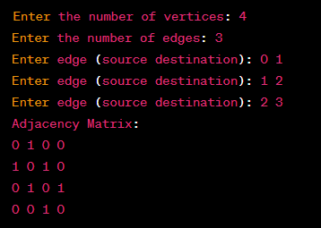

Figure 7.A: Output of the Implementation of a graph using adjacent matrix

Viva Questions:

- What is an adjacency matrix and how does it represent a graph?
An adjacency matrix is a 2D array where cell (i, j) indicates the presence of an edge.
A value of 1 (or weight) means there’s an edge between vertex i and j.
- How does the adjacency matrix differ when representing directed and undirected graphs?
In a directed graph, only matrix[i][j] is set for an edge from i to j.
In an undirected graph, both matrix[i][j] and matrix[j][i] are set.
- What is the space complexity of an adjacency matrix for a graph with V vertices?
The space complexity is O(V²), regardless of the number of edges.
- How would you check if an edge exists between two vertices using an adjacency matrix?
Simply check if matrix[i][j] ≠ 0 (or is true).
If so, an edge exists between vertex i and j.
- What are the advantages and disadvantages of using adjacency matrices compared to adjacency lists?
Advantages: Fast edge lookup (O(1)).
Disadvantages: High space usage (O(V²)), inefficient for sparse graphs.

Experiment No: 7.B

Objective: To implement BFS using Linked List.

Apparatus Used:Turbo C compiler, gcc compiler (VS Code, Dev C), GCC compiler or any standard C programming environment (e.g., Code:Blocks, Dev C++, Turbo C++), Operating System: Windows / Linux / macOS Text Editor or IDE

Theory:

Breadth-First Search (BFS) is a graph traversal algorithm that explores nodes level by level, starting from a given source node. It uses a queue to keep track of nodes to visit next. When the graph is represented using adjacency lists (often implemented with linked lists), BFS efficiently traverses all reachable vertices from the source.

Pseudocode:
Method BFS(graph, start):
create a queue Q
create a visited array initialized to False for all vertices

enqueue Q with start
visited[start] ← True

while Q is not empty:
node ← dequeue Q
print node

for each neighbor in adjacencyList[node]: // adjacencyList[node] is a linked list
if visited[neighbor] = False:
enqueue Q with neighbor
visited[neighbor] ← True

Program:
#include <stdio.h>
#include <stdlib.h>

struct Node {
int vertex;
struct Node* next;
};

struct Graph {
int vertices;
struct Node** adjList;
};

struct Node* createNode(int v) {
struct Node* newNode = (struct Node*)malloc(sizeof(struct Node));
newNode->vertex = v;
newNode->next = NULL;
return newNode;
}

struct Graph* createGraph(int vertices) {
struct Graph* graph = (struct Graph*)malloc(sizeof(struct Graph));
graph->vertices = vertices;

graph->adjList = (struct Node**)malloc(vertices * sizeof(struct Node*));

for (int i = 0; i < vertices; ++i) {
graph->adjList[i] = NULL;
}
return graph;
}

void addEdge(struct Graph* graph, int src, int dest) {
// Add edge from src to dest
struct Node* newNode = createNode(dest);
newNode->next = graph->adjList[src];
graph->adjList[src] = newNode;

// For undirected graph, add edge from dest to src as well
newNode = createNode(src);
newNode->next = graph->adjList[dest];
graph->adjList[dest] = newNode;
}

void bfs(struct Graph* graph, int startVertex) {
int* visited = (int*)malloc(graph->vertices * sizeof(int));
for (int i = 0; i < graph->vertices; ++i) {
visited[i] = 0;
}

struct Node* queue = NULL;
visited[startVertex] = 1;
printf("BFS Traversal from vertex %d: ", startVertex);

struct Node* temp = createNode(startVertex);
enqueue(&queue, temp);

while (!isEmpty(queue)) {
startVertex = dequeue(&queue);
printf("%d ", startVertex);

struct Node* trav = graph->adjList[startVertex];
while (trav) {
int adjVertex = trav->vertex;
if (visited[adjVertex] == 0) {
visited[adjVertex] = 1;
struct Node* newNode = createNode(adjVertex);
enqueue(&queue, newNode);
}
trav = trav->next;
}
}
printf("\n");
}

void enqueue(struct Node** head, struct Node* newNode) {
if (*head == NULL) {
*head = newNode;
} else {
struct Node* temp = *head;
while (temp->next != NULL) {
temp = temp->next;
}
temp->next = newNode;
}
}

int dequeue(struct Node** head) {
int val = (*head)->vertex;
*head = (*head)->next;
return val;
}

int isEmpty(struct Node* head) {
return (head == NULL);
}

int main() {
int vertices, edges, src, dest;
printf("Enter the number of vertices: ");
scanf("%d", &vertices);

struct Graph* graph = createGraph(vertices);

printf("Enter the number of edges: ");
scanf("%d", &edges);

for (int i = 0; i < edges; ++i) {
printf("Enter edge (source destination): ");
scanf("%d %d", &src, &dest);
addEdge(graph, src, dest);
}

int startVertex;
printf("Enter the starting vertex for BFS: ");
scanf("%d", &startVertex);

bfs(graph, startVertex);

return 0;
}

Output:

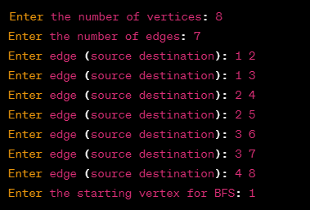

Figure 7.B: Output of the implementation of BFS using Linked List

Viva Questions:
- What is BFS and how does it work?
BFS (Breadth-First Search) is a graph traversal algorithm that visits nodes level by level.
It uses a queue to explore neighbors before going deeper.
- Why do we use a queue in BFS?
A queue maintains the order of nodes to be visited in FIFO fashion.
This ensures level-wise traversal from the source node.
- How is a graph represented using adjacency lists with linked lists?
Each vertex has a linked list of adjacent vertices.
This saves space and efficiently represents sparse graphs.
- What is the time complexity of BFS when using adjacency lists?
The time complexity is O(V + E), where V is vertices and E is edges.
Each node and edge is visited once.
- How does BFS differ when the graph is represented by an adjacency matrix instead of adjacency lists?
With an adjacency matrix, checking neighbors takes O(V) per node.
It's less space-efficient and slower for sparse graphs

Experiment No: 7.C

Objective: To implement any minimum spanning tree algorithm.

Apparatus Used:Turbo C compiler, gcc compiler (VS Code, Dev C), GCC compiler or any standard C programming environment (e.g., Code:Blocks, Dev C++, Turbo C++), Operating System: Windows / Linux / macOS Text Editor or IDE

Theory:
A Minimum Spanning Tree (MST) of a connected, weighted graph is a subset of edges that connects all vertices together without any cycles and with the minimum possible total edge weight.
Kruskal’s algorithm builds the MST by sorting all edges in ascending order of weight and adding them one by one, skipping those that form cycles, until all vertices are connected.
Pseudocode:
Method KruskalMST(graph):
result ← empty list to store MST edges
i ← 0 // index for sorted edges
e ← 0 // count of edges in MST

// Step 1: Sort all edges in non-decreasing order of weight
sort(graph.edges) by weight

create disjoint sets for each vertex (for cycle detection)

while e < (graph.V - 1):
edge ← graph.edges[i]
i ← i + 1

x ← findSet(edge.src)
y ← findSet(edge.dest)

if x ≠ y:
result.add(edge)
union(x, y)
e ← e + 1

return result

// Helper functions:
Method findSet(node):
// finds the representative of the set (with path compression)

Method union(x, y):
// merges two sets (union by rank)

Program:
#include <stdio.h>
#include <stdbool.h>
#define V 5 // Number of vertices in the graph

int minKey(int key[], bool mstSet[]) {
int min = INT_MAX, min_index;

for (int v = 0; v < V; v++) {
if (!mstSet[v] && key[v] < min) {
min = key[v];
min_index = v;
}
}

return min_index;
}

void printMST(int parent[], int graph[V][V]) {
printf("Edge Weight\n");
for (int i = 1; i < V; i++) {
printf("%d - %d %d\n", parent[i], i, graph[i][parent[i]]);
}
}

void primMST(int graph[V][V]) {
int parent[V];
int key[V];
bool mstSet[V];
for (int i = 0; i < V; i++) {
key[i] = INT_MAX;
mstSet[i] = false;
}
key[0] = 0;
parent[0] = -1;
for (int count = 0; count < V - 1; count++) {
int u = minKey(key, mstSet);
mstSet[u] = true;

for (int v = 0; v < V; v++) {
if (graph[u][v] && !mstSet[v] && graph[u][v] < key[v]) {
parent[v] = u;
key[v] = graph[u][v];
}
}
}
printMST(parent, graph);
}
int main() {
int graph[V][V] = {{0, 2, 0, 6, 0},
{2, 0, 3, 8, 5},
{0, 3, 0, 0, 7},
{6, 8, 0, 0, 9},
{0, 5, 7, 9, 0}};
printf("Minimum Spanning Tree using Prim's algorithm:\n");
primMST(graph);
return 0;
}

Output:

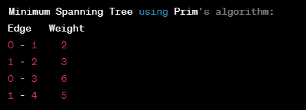

Figure 7.C: Output of the implementation of minimum spanning tree algorithm

Viva Questions:
- What is a Minimum Spanning Tree (MST) and why is it useful?
An MST is a subset of edges that connect all vertices with the minimum total weight and no cycles. It’s useful in network design, like minimizing cost in connecting systems.
- How does Kruskal’s algorithm work to find the MST?
It sorts all edges by weight and adds the smallest edge that doesn’t form a cycle.
This continues until (V - 1) edges are included.
- What data structure is used to detect cycles in Kruskal’s algorithm?
A Disjoint Set (Union-Find) data structure is used.
It efficiently checks and merges connected components.
- What is the time complexity of Kruskal’s algorithm?
Time complexity is O(E log E) due to edge sorting and union-find operations.
Efficient for sparse graphs.
- How does Kruskal’s algorithm differ from Prim’s algorithm?
Kruskal’s works on edges, adding the smallest ones globally.
Prim’s builds the MST from a starting vertex, growing the tree locally

Content Beyond Syllabus

S.No. | List of Experiments | CO
8.A | To implement Count Sort. | CO1
8.B | To implement B+ Tree | CO3
8.C | To implement Red Black Tree | CO3

Experiment No: 8.A

Objective: To implement counting sort.

Apparatus Used: Turbo C compiler, gcc compiler (VS Code, Dev C), GCC compiler or any standard C programming environment (e.g., Code:Blocks, Dev C++, Turbo C++), Operating System: Windows / Linux / macOS Text Editor or IDE

Theory:

Counting Sort is a non-comparison-based sorting algorithm suitable for sorting integers within a known, limited range. It counts the occurrences of each value, then calculates the positions of each value in the sorted output.

Pseudocode:
Method countingSort(arr):
maxVal ← maximum value in arr
minVal ← minimum value in arr
range ← maxVal - minVal + 1

count ← array of size range initialized to 0
output ← array of same size as arr

// Count occurrences
for i in 0 to length(arr) - 1:
count[arr[i] - minVal] ← count[arr[i] - minVal] + 1

// Modify count to store cumulative counts
for i in 1 to range - 1:
count[i] ← count[i] + count[i - 1]

// Build output array
for i in length(arr) - 1 down to 0:
output[count[arr[i] - minVal] - 1] ← arr[i]
count[arr[i] - minVal] ← count[arr[i] - minVal] - 1

// Copy output to arr
for i in 0 to length(arr) - 1:
arr[i] ← output[i]

Program:
#include <stdio.h>
#include <stdlib.h>
void countingSort(int arr[], int n) {
int max = arr[0];
int min = arr[0];
// Find the maximum and minimum values in the array
for (int i = 1; i < n; i++) {
if (arr[i] > max) {
max = arr[i];
}
if (arr[i] < min) {
min = arr[i];
}
}
int range = max - min + 1;
// Create a count array to store the count of each element
int* count = (int*)malloc(range * sizeof(int));
int* output = (int*)malloc(n * sizeof(int));

for (int i = 0; i < range; i++) {
count[i] = 0;
}

// Count the occurrences of each element
for (int i = 0; i < n; i++) {
count[arr[i] - min]++;
}

// Calculate the cumulative count
for (int i = 1; i < range; i++) {
count[i] += count[i - 1];
}

// Build the sorted output array
for (int i = n - 1; i >= 0; i--) {
output[count[arr[i] - min] - 1] = arr[i];
count[arr[i] - min]--;
}

// Copy the sorted elements back to the original array
for (int i = 0; i < n; i++) {
arr[i] = output[i];
}

free(count);
free(output);
}

int main() {
int arr[] = {4, 2, 2, 8, 3, 3, 1};
int n = sizeof(arr) / sizeof(arr[0]);

printf("Original Array: ");
for (int i = 0; i < n; i++) {
printf("%d ", arr[i]);
}

countingSort(arr, n);

printf("\nSorted Array: ");
for (int i = 0; i < n; i++) {
printf("%d ", arr[i]);
}

printf("\n");

return 0;
}

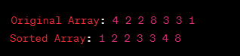
Output:

Figure 8.A: Output of the implementation of counting sort.

Viva Questions:
- What is counting sort and when is it used?
Counting sort is a non-comparison-based sorting algorithm used for integers in a limited range.
It counts the frequency of each value and uses it to build the sorted output.
- What is the time complexity of counting sort?
The time complexity is O(n + k), where n is the number of elements and k is the range of input values.
- Can counting sort be used to sort negative numbers? If yes, how?
Yes, by offsetting all numbers so the smallest becomes zero.
Adjust the count array index accordingly.
- What are the space requirements of counting sort?
It requires O(k) extra space for the count array and O(n) for the output array.
- How does counting sort differ from comparison-based sorting algorithms?
Counting sort does not compare elements; it relies on value frequencies.
It's faster than comparison sorts for small, known ranges

Experiment 8.B
Objective: To implement B+ Tree.
Apparatus Used:Turbo C compiler, gcc compiler (VS Code, Dev C), GCC compiler or any standard C programming environment (e.g., Code:Blocks, Dev C++, Turbo C++), Operating System: Windows / Linux / macOS Text Editor or IDE

Theory:
A B+ Tree is a balanced tree data structure commonly used in databases and file systems. It maintains sorted data and allows searches, sequential access, insertions, and deletions in logarithmic time.
- Internal nodes store only keys (used for navigation).
- All actual data records are stored at the leaf nodes, which are linked for efficient range queries.
Pseudocode:
Class BPlusTree:
root
order // max number of children per node

Method search(key):
node ← root
while node is not leaf:
find the child pointer to follow based on key
node ← child pointer
search key in leaf node
return result

Method insert(key, value):
leaf ← find leaf node to insert key
insert key and value in leaf node

if leaf is overflow:
splitLeaf(leaf)

Method splitLeaf(leaf):
create new leaf node
move half of leaf's keys and values to new leaf
update linked list pointers of leaves
insert new key in parent

Method insertInParent(node, key, newNode):
if node is root:
create new root with pointers to node and newNode
return
parent ← node.parent
insert key and pointer to newNode in parent
if parent is overflow:
splitInternal(parent)

Method splitInternal(node):
create new internal node
move half keys and children to new node
promote middle key to parent
if parent overflow, repeat splitting

Program:

#include <stdio.h>
#include <stdlib.h>
#include <stdbool.h>

#define ORDER 3 // Max keys per node

typedef struct BPlusNode {
int keys[ORDER - 1];
struct BPlusNode* children[ORDER];
struct BPlusNode* next; // For leaf nodes linked list
int num_keys;
bool leaf;
} BPlusNode;

typedef struct BPlusTree {
BPlusNode* root;
} BPlusTree;

// Function prototypes
BPlusNode* createNode(bool leaf);
void insert(BPlusTree* tree, int key);
void insertNonFull(BPlusNode* node, int key);
void splitChild(BPlusNode* parent, int index);
void display(BPlusNode* node, int level);
int search(BPlusNode* node, int key);

// Create a new node
BPlusNode* createNode(bool leaf) {
BPlusNode* node = (BPlusNode*)malloc(sizeof(BPlusNode));
node->leaf = leaf;
node->num_keys = 0;
node->next = NULL;
for(int i=0; i<ORDER; i++)
node->children[i] = NULL;
return node;
}

// Search key in subtree rooted at node
int search(BPlusNode* node, int key) {
int i=0;
while(i < node->num_keys && key > node->keys[i])
i++;
if (i < node->num_keys && key == node->keys[i]) {
if(node->leaf)
return 1; // Found in leaf
else
return search(node->children[i+1], key);
}
if(node->leaf)
return 0; // Not found
else
return search(node->children[i], key);
}

// Insert key into the B+ Tree
void insert(BPlusTree* tree, int key) {
BPlusNode* root = tree->root;
if(root->num_keys == ORDER - 1) {
BPlusNode* new_root = createNode(false);
new_root->children[0] = root;
splitChild(new_root, 0);
tree->root = new_root;
}
insertNonFull(tree->root, key);
}

// Insert key into node which is not full
void insertNonFull(BPlusNode* node, int key) {
int i = node->num_keys - 1;
if(node->leaf) {
// Find position and insert key
while(i >=0 && node->keys[i] > key) {
node->keys[i+1] = node->keys[i];
i--;
}
node->keys[i+1] = key;
node->num_keys++;
} else {
// Find child to recurse
while(i >=0 && node->keys[i] > key)
i--;
i++;
if(node->children[i]->num_keys == ORDER -1) {
splitChild(node, i);
if(key > node->keys[i])
i++;
}
insertNonFull(node->children[i], key);
}
}

// Split the child node of parent at index
void splitChild(BPlusNode* parent, int index) {
BPlusNode* node = parent->children[index];
BPlusNode* new_node = createNode(node->leaf);
int mid = (ORDER - 1)/2;

new_node->num_keys = node->num_keys - mid - 1;
// Move keys and children
for(int j=0; j<new_node->num_keys; j++)
new_node->keys[j] = node->keys[mid+1+j];

if(!node->leaf) {
for(int j=0; j<=new_node->num_keys; j++)
new_node->children[j] = node->children[mid+1+j];
} else {
new_node->next = node->next;
node->next = new_node;
}

node->num_keys = mid;

// Shift parent's children and keys
for(int j=parent->num_keys; j>index; j--) {
parent->children[j+1] = parent->children[j];
parent->keys[j] = parent->keys[j-1];
}
parent->children[index+1] = new_node;
parent->keys[index] = node->keys[mid];
parent->num_keys++;
}

// Display tree keys level-wise (simple)
void display(BPlusNode* node, int level) {
printf("Level %d: ", level);
for(int i=0; i < node->num_keys; i++)
printf("%d ", node->keys[i]);
printf("\n");

if(!node->leaf) {
for(int i=0; i <= node->num_keys; i++)
display(node->children[i], level + 1);
}
}

int main() {
BPlusTree tree;
tree.root = createNode(true);

int keys[] = {10, 20, 5, 6, 12, 30, 7, 17};
int n = sizeof(keys)/sizeof(keys[0]);

for(int i=0; i<n; i++)
insert(&tree, keys[i]);

printf("B+ Tree structure:\n");
display(tree.root, 0);

// Search keys
int search_keys[] = {6, 15, 17};
for(int i=0; i<3; i++) {
int found = search(tree.root, search_keys[i]);
if(found)
printf("Key %d found in B+ Tree\n", search_keys[i]);
else
printf("Key %d not found in B+ Tree\n", search_keys[i]);
}

return 0;
}

Output:

B+ Tree structure:
Level 0: 12 20
Level 1: 5 6 7
Level 1: 10 17
Level 1: 30
Key 6 found in B+ Tree
Key 15 not found in B+ Tree
Key 17 found in B+ Tree

Figure 8.B: Output of the implementation of B+ Tree.

Viva Questions:
- What is a B+ Tree and how does it differ from a B-Tree?
A B+ Tree stores all records at the leaf nodes, while a B-Tree stores data in both internal and leaf nodes.
B+ Trees also have linked leaf nodes for efficient range queries.
- Why are all records stored only at the leaf nodes in a B+ Tree?
This ensures a uniform structure and makes range and full scans faster.
Internal nodes serve only as routing indexes.
- How does insertion work in a B+ Tree when a node overflows?
The node is split, and the middle key is promoted to the parent.
This may propagate upward, possibly creating a new root.
- What are the advantages of using B+ Trees in databases?
B+ Trees support efficient range queries, faster disk access, and balanced tree height.
They are optimized for block-based storage like hard disks.
- How does the linked list between leaf nodes help in range queries?
It allows sequential access across leaves without backtracking.
This makes range and sorted queries very fast and efficient.

Experiment 8.C

Objective: To implement Red Black Tree.

Apparatus Used: Turbo C compiler, gcc compiler (VS Code, Dev C), GCC compiler or any standard C programming environment (e.g., Code:Blocks, Dev C++, Turbo C++), Operating System: Windows / Linux / macOS Text Editor or IDE

Theory:
A Red-Black Tree is a self-balancing binary search tree where each node has a color attribute (red or black) that ensures the tree remains approximately balanced during insertions and deletions. This guarantees O(log n) time complexity for search, insert, and delete operations.
Properties:
- Every node is either red or black.
- The root is black.
- All leaves (NULL pointers) are black.
- Red nodes cannot have red children (no two reds in a row).
- Every path from a node to its descendant NULL nodes has the same number of black nodes
Pseudocode:
Method RB_Insert(tree, newNode):
BST_Insert(tree, newNode) // Insert node like in BST and color it RED
newNode.color ← RED
FixViolation(tree, newNode)

Method FixViolation(tree, node):
WHILE node ≠ root AND node.parent.color == RED:
parent ← node.parent
grandparent ← parent.parent

IF parent is left child of grandparent:
uncle ← grandparent.right
IF uncle.color == RED:
parent.color ← BLACK
uncle.color ← BLACK
grandparent.color ← RED
node ← grandparent
ELSE
IF node is right child:
node ← parent
LeftRotate(tree, node)
parent.color ← BLACK
grandparent.color ← RED
RightRotate(tree, grandparent)
ELSE
uncle ← grandparent.left
IF uncle.color == RED:
parent.color ← BLACK
uncle.color ← BLACK
grandparent.color ← RED
node ← grandparent
ELSE
IF node is left child:
node ← parent
RightRotate(tree, node)
parent.color ← BLACK
grandparent.color ← RED
LeftRotate(tree, grandparent)

root.color ← BLACK

Program:

#include <stdio.h>
#include <stdlib.h>

typedef enum { RED, BLACK } Color;

typedef struct Node {
int data;
Color color;
struct Node *left, *right, *parent;
} Node;

Node* createNode(int data) {
Node* newNode = (Node*)malloc(sizeof(Node));
newNode->data = data;
newNode->color = RED;
newNode->left = newNode->right = newNode->parent = NULL;
return newNode;
}

Node* BSTInsert(Node* root, Node* pt) {
if (root == NULL)
return pt;

if (pt->data < root->data) {
root->left = BSTInsert(root->left, pt);
root->left->parent = root;
}
else if (pt->data > root->data) {
root->right = BSTInsert(root->right, pt);
root->right->parent = root;
}
return root;
}

void leftRotate(Node** root, Node* x) {
Node* y = x->right;
x->right = y->left;
if (y->left != NULL) y->left->parent = x;
y->parent = x->parent;

if (x->parent == NULL) *root = y;
else if (x == x->parent->left) x->parent->left = y;
else x->parent->right = y;

y->left = x;
x->parent = y;
}

void rightRotate(Node** root, Node* y) {
Node* x = y->left;
y->left = x->right;
if (x->right != NULL) x->right->parent = y;
x->parent = y->parent;

if (y->parent == NULL) *root = x;
else if (y == y->parent->left) y->parent->left = x;
else y->parent->right = x;

x->right = y;
y->parent = x;
}

void fixViolation(Node** root, Node* pt) {
Node *parent_pt = NULL;
Node *grand_parent_pt = NULL;

while ((pt != *root) && (pt->color != BLACK) && (pt->parent->color == RED)) {
parent_pt = pt->parent;
grand_parent_pt = parent_pt->parent;

if (parent_pt == grand_parent_pt->left) {
Node* uncle_pt = grand_parent_pt->right;

if (uncle_pt != NULL && uncle_pt->color == RED) {
grand_parent_pt->color = RED;
parent_pt->color = BLACK;
uncle_pt->color = BLACK;
pt = grand_parent_pt;
} else {
if (pt == parent_pt->right) {
leftRotate(root, parent_pt);
pt = parent_pt;
parent_pt = pt->parent;
}
rightRotate(root, grand_parent_pt);
Color temp = parent_pt->color;
parent_pt->color = grand_parent_pt->color;
grand_parent_pt->color = temp;
pt = parent_pt;
}
} else {
Node* uncle_pt = grand_parent_pt->left;

if ((uncle_pt != NULL) && (uncle_pt->color == RED)) {
grand_parent_pt->color = RED;
parent_pt->color = BLACK;
uncle_pt->color = BLACK;
pt = grand_parent_pt;
} else {
if (pt == parent_pt->left) {
rightRotate(root, parent_pt);
pt = parent_pt;
parent_pt = pt->parent;
}
leftRotate(root, grand_parent_pt);
Color temp = parent_pt->color;
parent_pt->color = grand_parent_pt->color;
grand_parent_pt->color = temp;
pt = parent_pt;
}
}
}
(*root)->color = BLACK;
}

void insert(Node** root, int data) {
Node* pt = createNode(data);
*root = BSTInsert(*root, pt);
fixViolation(root, pt);
}

void inorderHelper(Node* root) {
if (root == NULL) return;
inorderHelper(root->left);
printf("%d(%s) ", root->data, root->color == RED ? "R" : "B");
inorderHelper(root->right);
}

void inorder(Node* root) {
inorderHelper(root);
printf("\n");
}

int main() {
Node* root = NULL;

int keys[] = {10, 20, 30, 15, 25, 5};
int n = sizeof(keys)/sizeof(keys[0]);

for (int i = 0; i < n; i++) {
insert(&root, keys[i]);
printf("Inorder after inserting %d: ", keys[i]);
inorder(root);
}

return 0;
}

Output:

Inorder after inserting 10: 10(B)
Inorder after inserting 20: 10(B) 20(R)
Inorder after inserting 30: 20(B) 10(R) 30(R)
Inorder after inserting 15: 20(B) 10(B) 15(R) 30(B)
Inorder after inserting 25: 20(B) 10(B) 15(R) 25(R) 30(B)
Inorder after inserting 5: 20(B) 10(B) 5(R) 15(R) 25(R) 30(B)

Figure 8.C: Output of the implementation of Red Black Tree

Viva Questions:
- What properties must a Red-Black Tree satisfy?
- Each node is either red or black.
- The tree must have no two consecutive red nodes, the root is black, and all paths from a node to its leaves must contain the same number of black nodes.
- Why is the Red-Black Tree considered a balanced tree?
It ensures the longest path is no more than twice as long as the shortest, maintaining logarithmic height.
This keeps operations efficient.
- What cases are handled during insertion fix-up?
Cases include recoloring and rotations to restore red-black properties.
It handles violations like consecutive red nodes.
- How do rotations work and why are they needed?
Left and right rotations restructure the tree to maintain balance.
They are essential during insertions and deletions to preserve tree properties.
- What is the time complexity of search, insert, and delete in Red-Black Trees?
All three operations take O(log n) time.
The tree’s balanced height ensures consistent performance

Viva Questions – Answer Key

1.A
- What is Bubble Sort and how does it work?
Bubble Sort is a simple algorithm that repeatedly swaps adjacent elements if they are in the wrong order. It continues until the entire list is sorted.
- What is the time complexity of Bubble Sort in best, average, and worst cases?
Best case is O(n), average and worst cases are O(n²) due to nested iterations over the array.
- How can Bubble Sort be optimized?
It can be optimized by using a swapped flag to stop early if no swaps occur in a pass.
- Why is Bubble Sort not suitable for large datasets?
Because of its O(n²) time complexity, it's inefficient and slow for sorting large amounts of data.
- What is the difference between Bubble Sort and Selection Sort?
Bubble Sort swaps adjacent elements repeatedly, while Selection Sort selects the minimum element and swaps it once per pass.
1.B
- What is Insertion Sort and how does it work?
Insertion Sort builds the sorted array one item at a time by comparing and inserting each element into its correct position. It works like sorting playing cards in hand.
- What is the time complexity of Insertion Sort in best and worst cases?
Best case (already sorted): O(n); Worst case (reverse order): O(n²) due to shifting elements.
- How is Insertion Sort different from Bubble Sort?
Insertion Sort inserts elements into their correct position, while Bubble Sort repeatedly swaps adjacent elements. Insertion Sort is generally more efficient.
- Is Insertion Sort stable and in-place? Explain.
Yes, it's stable (maintains relative order of equal elements) and in-place (uses no extra memory).
- When is Insertion Sort preferred over other sorting algorithms?
It's preferred for small datasets or nearly sorted arrays due to its simplicity and low overhead.
1.C
- What is Selection Sort and how does it work?
Selection Sort repeatedly selects the smallest element from the unsorted portion and swaps it with the first unsorted element. This process continues until the list is sorted.
- What is the time complexity of Selection Sort in all cases?
Time complexity is O(n²) in best, average, and worst cases due to two nested loops.
- Is Selection Sort stable? Why or why not?
No, it's not stable because it may swap non-adjacent elements, changing the order of equal elements.
- How does Selection Sort differ from Insertion Sort?
Selection Sort selects the minimum and swaps once per pass, while Insertion Sort shifts elements to insert them correctly.
- Why is Selection Sort not preferred for large datasets?
Due to its O(n²) time complexity and lack of efficiency, it's slow and impractical for large datasets.
1.D
- What is the time complexity of Quick Sort in the average, worst, and best cases?
Best and average case: O(n log n); Worst case (poor pivot): O(n²) due to unbalanced partitions.
- How does Quick Sort differ from Merge Sort?
Quick Sort is in-place and uses partitioning; Merge Sort uses extra space and merges sorted halves.
- What strategies can be used to choose a pivot effectively?
Use random pivot, median-of-three, or middle element to reduce chances of worst-case partitions.
- What are the advantages and disadvantages of Quick Sort?
It’s fast and efficient on average, but has a worst-case time of O(n²) and is not stable by default.
- In what scenarios would you prefer Quick Sort over other sorting algorithms?
Quick Sort is preferred for large datasets and in-place sorting when average-case performance matters most.
2.A
- Explain the time complexity of linear and binary search.
Linear search has O(n) time complexity; binary search has O(log n) but requires a sorted array.
- What is hashing, and why is it useful?
Hashing maps keys to indices in a table using a hash function, enabling fast data access in O(1) average time.
- How does collision resolution work in hashing?
When two keys map to the same index, collision resolution techniques like chaining or probing are used to store them.
- Can you explain how linear probing works?
In linear probing, if a collision occurs, the algorithm checks the next slot linearly until an empty one is found.
- What are the advantages of binary search over linear search?
Binary search is much faster on large, sorted data (O(log n)) compared to linear search’s O(n) time.

2.B
- Explain the time complexity of linear and binary search.
Linear search takes O(n) time as it checks each element one by one.
Binary search takes O(log n) but works only on sorted arrays.
- What is hashing, and why is it useful?
Hashing uses a hash function to map data to a fixed-size table for quick access.
It allows constant time lookups, insertions, and deletions on average.
- How does collision resolution work in hashing?
Collision resolution handles cases where multiple keys hash to the same index.
Methods include chaining and open addressing (like linear probing).
- Can you explain how linear probing works?
In linear probing, if a spot is occupied, the algorithm checks the next index linearly.
It continues until it finds an empty slot or the key.
- What are the advantages of binary search over linear search?
Binary search is faster (O(log n)) and more efficient on large, sorted data.
Linear search is simpler but slower, especially on large lists.
3.A
- What is a stack and how is it implemented using an array?
A stack is a LIFO data structure where elements are added and removed from the top.
It's implemented using an array and a variable (e.g., top) to track the index of the last element.
- What are the advantages and limitations of implementing a stack using an array?
Advantages: Simple, fast access via indexing.
Limitations: Fixed size, risk of overflow if capacity is exceeded.
- How do you check if a stack is full or empty in array implementation?
Stack is empty if top == -1, and full if top == size - 1.
These checks prevent overflow and underflow errors.
- What is the time complexity of push and pop operations in an array-based stack?
Both push and pop operations run in O(1) time.
They involve direct index manipulation.
- How do you handle stack overflow and underflow conditions in array implementation?
Overflow is handled by checking if the stack is full before pushing.
Underflow is handled by checking if the stack is empty before popping.
3.B
- How is a stack implemented using a linked list?
A stack uses a linked list where elements are added and removed from the head.
The top points to the head node, and push/pop updates this pointer.
- What are the advantages of using a linked list over an array for stack implementation?
Linked lists provide dynamic sizing, avoiding overflow issues.
No need to resize or allocate memory in advance.
- Which end of the linked list is used for push and pop operations in a stack and why?
The head is used for both operations to achieve O(1) time complexity.
Modifying the head avoids traversal and ensures efficiency.
- What is the time complexity of stack operations using a linked list?
Both push and pop operations take O(1) time.
This is because they involve only head pointer updates.
- How do you detect stack underflow in a linked list implementation?
Underflow occurs when pop is called on an empty stack.
Check if the top (head) is null before popping.

3.C
- What is an infix expression?
An infix expression places operators between operands, e.g., A + B.
It’s the standard way humans write mathematical expressions.
- Why is postfix notation preferred over infix in some computations?
Postfix eliminates the need for parentheses and follows strict operator precedence, making evaluation easier for computers.
- How does the Shunting Yard algorithm work for converting infix to postfix expressions?
It uses a stack to reorder operators based on precedence and associativity.
Operands go directly to output; operators are pushed/popped according to rules.
- Give an example of converting an infix expression to postfix using the Shunting Yard algorithm.
Infix: (A + B) * C → Postfix: A B + C *
The algorithm handles parentheses and operator precedence via a stack.
- How do you evaluate a postfix expression once it's converted?
Scan left to right, push operands, and on an operator, pop two operands, apply the operator, and push the result.
4.A
- What is a Queue and how does it differ from other data structures like stacks?
A Queue follows FIFO (First In, First Out) order, where elements are added at the rear and removed from the front.
In contrast, a stack follows LIFO (Last In, First Out) order.
- Why would you implement a Queue using a Linked List instead of an array?
A linked list allows dynamic memory allocation, avoiding fixed size limits.
It’s more efficient for frequent enqueue/dequeue without shifting elements.
- Explain the process of enqueue and dequeue operations in a Queue implemented using a Linked List.
Enqueue inserts a node at the rear; dequeue removes a node from the front.
Both operations run in O(1) time with front and rear pointers.
- How do you handle the case when the Queue is empty during a dequeue operation?
Check if the front is null before dequeueing.
If it is, report underflow or return an error/indicator.
- What are the advantages and disadvantages of using a Linked List to implement a Queue?
Advantages: Dynamic size, no need for resizing, efficient operations.
Disadvantages: More complex, uses extra memory for pointers.
4.B
- What is a circular queue and how is it different from a simple linear queue?
A circular queue connects the end of the array back to the front, forming a circle.
Unlike a linear queue, it reuses freed space, avoiding wasted memory.
- Why do we use a circular queue instead of a linear queue in some cases?
Circular queues optimize space by reusing empty slots.
Linear queues can lead to unused space even when not full.
- How do you determine if a circular queue is full or empty?
It's full if (rear + 1) % size == front; empty if front == -1.
These conditions prevent overflow and underflow.
- Explain how the front and rear pointers move in a circular queue implemented using an array.
Both pointers move circularly using (index + 1) % size.
This ensures they wrap around to the beginning when reaching the end.
- What is the advantage of using a circular queue over a normal queue implemented with an array?
Circular queues maximize memory usage by reusing freed space.
They prevent the need for shifting elements or resizing.
4.C
- What is a priority queue and how does it differ from a regular queue?
A priority queue removes elements based on priority, not insertion order.
In a regular queue, elements follow FIFO without priority consideration.
- How do you maintain the order of elements in a priority queue implemented with a linked list?
Insert elements in sorted order based on priority.
The highest (or lowest) priority element stays at the front.
- What is the time complexity of insertion and deletion operations in a priority queue using a linked list?
Insertion takes O(n) (to find correct position), and deletion takes O(1) (from front).
This maintains correct priority order.
- How do you handle multiple elements with the same priority in the priority queue?
Insert them in the order they arrive to maintain stability.
This ensures FIFO among equal-priority elements.
- Why might a linked list be preferred over an array for implementing a priority queue?
Linked lists offer dynamic size and easier insertion at any point.
Arrays may require shifting or resizing, which is less efficient.
5.A
- What is a singly linked list and how does it differ from an array?
A singly linked list is a collection of nodes where each node points to the next node.
Unlike arrays, it provides dynamic sizing and non-contiguous memory storage.
- How do you insert a new node at the beginning of a singly linked list?
Create a new node, set its next to the current head, then update head to the new node.
This operation takes O(1) time.
- What are the advantages of using a singly linked list over an array?
It allows dynamic memory allocation and efficient insertions/deletions.
No need to shift elements or define a fixed size.
- How do you traverse a singly linked list?
Start from the head and follow each node’s next pointer until null.
Visit or process each node during the traversal.
- What happens if you try to delete a node from an empty singly linked list?
The operation fails or throws an underflow error.
Always check if head is null before deletion.
5.B
- What is a circular linked list and how does it differ from a singly linked list?
In a circular linked list, the last node points back to the head, forming a circle.
In a singly linked list, the last node points to null.
- How do you identify the end of a circular linked list during traversal?
Start from the head and continue until the current node's next is head again.
This indicates a full cycle and the end of traversal.
5.C
- What is a doubly linked list and how does it differ from a singly linked list?
A doubly linked list has nodes with next and prev pointers, allowing bidirectional traversal.
A singly linked list only has next pointers and allows one-way traversal.
- How do you insert a node at the beginning of a doubly linked list?
Create a new node, set its next to the current head and prev to null.
Update the old head’s prev to the new node and set head to the new node.
- Explain how backward traversal is possible in a doubly linked list.
Each node has a prev pointer, allowing traversal from the tail to the head.
Start at the tail and follow the prev links.
- What are the advantages and disadvantages of doubly linked lists?
Advantages: Easy bidirectional traversal, efficient insertion/deletion from both ends.
Disadvantages: Uses more memory and is more complex to manage than singly linked lists.
- How do you delete a node from the beginning of a doubly linked list?
Move head to head.next, then set the new head's prev to null.
Free the memory of the original head node.
5.D
- How are polynomials represented in linked lists?
Each node in the linked list stores a coefficient and an exponent.
Nodes are usually arranged in descending order of exponents.
- How does polynomial addition work?
Traverse both lists simultaneously, comparing exponents.
Add coefficients if exponents match, else copy the term with the higher exponent.
- What happens when terms with the same exponent are found?
Their coefficients are added, and a single node is created for the resulting term.
If the sum is zero, the term can be skipped.
- Why is a linked list preferred over arrays for polynomial operations?
Linked lists allow dynamic size and efficient insertion/deletion of terms.
Arrays waste space when exponents are sparse or unordered.
- Can polynomial multiplication also be done using linked lists?
Yes, multiply each term of the first list with every term of the second.
Combine like terms using a new linked list to store the result
6.A
- What is a Binary Search Tree and how is it different from a binary tree?
A Binary Search Tree (BST) is a binary tree where left < root < right for all nodes.
A regular binary tree has no ordering rules for node values.
- How does the insert operation work in a BST?
Compare the new value with the current node and recursively insert left or right.
Place the new node where the correct empty position is found.
- What are the time complexities of search, insertion, and deletion in a BST?
Average case: O(log n); Worst case (unbalanced tree): O(n).
Balanced BSTs maintain efficient performance.
- Explain the inorder traversal of a BST and its significance.
Inorder traversal visits nodes in Left → Root → Right order.
It produces a sorted sequence of values in a BST
6.B
- What is the difference between preorder, inorder, and postorder traversal?
- Preorder: Root → Left → Right
- Inorder: Left → Root → Right
- Postorder: Left → Right → Root
- In what order are the nodes visited in an inorder traversal of a binary search tree?
Nodes are visited in ascending sorted order: Left subtree → Node → Right subtree.
- Why do we use recursion for tree traversals? Can tree traversal be implemented iteratively?
Recursion simplifies traversal using the call stack for backtracking.
Yes, tree traversal can be done iteratively using an explicit stack.
- What are some practical applications of preorder, inorder, and postorder traversals?
- Preorder: Copying a tree, prefix expression generation
- Inorder: Sorting BST elements
- Postorder: Deleting a tree, postfix evaluation
- How does the base condition in recursive traversal functions prevent infinite recursion?
The base case checks if the current node is null.
It stops further recursive calls, preventing infinite loops
6.C
- What is heap sort and how does it work?
Heap sort is a comparison-based sorting algorithm that uses a binary heap.
It builds a heap, then repeatedly extracts the root (max/min) to sort the array.
- What is a max heap and how is it used in heap sort?
A max heap is a binary tree where each parent is greater than or equal to its children.
Heap sort uses it to place the largest element at the root for extraction.
- What is the time complexity of heap sort in best, average, and worst cases?
Time complexity is O(n log n) in all cases.
It offers consistent performance regardless of input.
- How does the heapify function work?
Heapify ensures the heap property by comparing a node with its children and swapping if needed.
It recursively applies this down the subtree to maintain order.
- What are the advantages of heap sort compared to other sorting algorithms like quicksort or mergesort?
Heap sort has no worst-case degradation and needs no extra space (in-place).
Unlike quicksort, it guarantees O(n log n) performance in all cases.
7.A
- What is an adjacency matrix and how does it represent a graph?
An adjacency matrix is a 2D array where cell (i, j) indicates the presence of an edge.
A value of 1 (or weight) means there’s an edge between vertex i and j.
- How does the adjacency matrix differ when representing directed and undirected graphs?
In a directed graph, only matrix[i][j] is set for an edge from i to j.
In an undirected graph, both matrix[i][j] and matrix[j][i] are set.
- What is the space complexity of an adjacency matrix for a graph with V vertices?
The space complexity is O(V²), regardless of the number of edges.
- How would you check if an edge exists between two vertices using an adjacency matrix?
Simply check if matrix[i][j] ≠ 0 (or is true).
If so, an edge exists between vertex i and j.
- What are the advantages and disadvantages of using adjacency matrices compared to adjacency lists?
Advantages: Fast edge lookup (O(1)).
Disadvantages: High space usage (O(V²)), inefficient for sparse graphs.
7.B
- What is BFS and how does it work?
BFS (Breadth-First Search) is a graph traversal algorithm that visits nodes level by level.
It uses a queue to explore neighbors before going deeper.
- Why do we use a queue in BFS?
A queue maintains the order of nodes to be visited in FIFO fashion.
This ensures level-wise traversal from the source node.
- How is a graph represented using adjacency lists with linked lists?
Each vertex has a linked list of adjacent vertices.
This saves space and efficiently represents sparse graphs.
- What is the time complexity of BFS when using adjacency lists?
The time complexity is O(V + E), where V is vertices and E is edges.
Each node and edge is visited once.
- How does BFS differ when the graph is represented by an adjacency matrix instead of adjacency lists?
With an adjacency matrix, checking neighbors takes O(V) per node.
It's less space-efficient and slower for sparse graphs
7.C
- What is a Minimum Spanning Tree (MST) and why is it useful?
An MST is a subset of edges that connect all vertices with the minimum total weight and no cycles.
It’s useful in network design, like minimizing cost in connecting systems.
- How does Kruskal’s algorithm work to find the MST?
It sorts all edges by weight and adds the smallest edge that doesn’t form a cycle.
This continues until (V - 1) edges are included.
- What data structure is used to detect cycles in Kruskal’s algorithm?
A Disjoint Set (Union-Find) data structure is used.
It efficiently checks and merges connected components.
- What is the time complexity of Kruskal’s algorithm?
Time complexity is O(E log E) due to edge sorting and union-find operations.
Efficient for sparse graphs.
- How does Kruskal’s algorithm differ from Prim’s algorithm?
Kruskal’s works on edges, adding the smallest ones globally.
Prim’s builds the MST from a starting vertex, growing the tree locally

8.A
- What is counting sort and when is it used?
Counting sort is a non-comparison-based sorting algorithm used for integers in a limited range.
It counts the frequency of each value and uses it to build the sorted output.
- What is the time complexity of counting sort?
The time complexity is O(n + k), where n is the number of elements and k is the range of input values.
- Can counting sort be used to sort negative numbers? If yes, how?
Yes, by offsetting all numbers so the smallest becomes zero.
Adjust the count array index accordingly.
- What are the space requirements of counting sort?
It requires O(k) extra space for the count array and O(n) for the output array.
- How does counting sort differ from comparison-based sorting algorithms?
Counting sort does not compare elements; it relies on value frequencies.
It's faster than comparison sorts for small, known ranges
8.B
- What is a B+ Tree and how does it differ from a B-Tree?
A B+ Tree stores all records at the leaf nodes, while a B-Tree stores data in both internal and leaf nodes.
B+ Trees also have linked leaf nodes for efficient range queries.
- Why are all records stored only at the leaf nodes in a B+ Tree?
This ensures a uniform structure and makes range and full scans faster.
Internal nodes serve only as routing indexes.
- How does insertion work in a B+ Tree when a node overflows?
The node is split, and the middle key is promoted to the parent.
This may propagate upward, possibly creating a new root.
- What are the advantages of using B+ Trees in databases?
B+ Trees support efficient range queries, faster disk access, and balanced tree height.
They are optimized for block-based storage like hard disks.
- How does the linked list between leaf nodes help in range queries?
It allows sequential access across leaves without backtracking.
This makes range and sorted queries very fast and efficient.
8.C
- What properties must a Red-Black Tree satisfy?
- Each node is either red or black.
- The tree must have no two consecutive red nodes, the root is black, and all paths from a node to its leaves must contain the same number of black nodes.
- Why is the Red-Black Tree considered a balanced tree?
It ensures the longest path is no more than twice as long as the shortest, maintaining logarithmic height.
This keeps operations efficient.
- What cases are handled during insertion fix-up?
Cases include recoloring and rotations to restore red-black properties.
It handles violations like consecutive red nodes.
- How do rotations work and why are they needed?
Left and right rotations restructure the tree to maintain balance.
They are essential during insertions and deletions to preserve tree properties.
- What is the time complexity of search, insert, and delete in Red-Black Trees?
All three operations take O(log n) time.
The tree’s balanced height ensures consistent performance

